The Rotary Club of Wilmington, Delaware
Celebrating over 100 Years of Fellowship and Service
ISSUE 7 2016-2017 AUGUST 25 – SEPTEMBER 1
UPCOMING PROGRAMS

August 25
Adriana LaCorte & Pina De Rosa
Freelance Documentary Producers
“Sniffing out Cancer: The Making of a Groundbreaking Documentary about Early Cancer Detection”
Program Chair: Ajit George
Menu: Grilled Flank Steak, Roasted Red-Skin Potatoes, Vegetable

September 1 – Tim McDermott, Chief Business Officer, Philadelphia Union
Program Chair: Matt Stehl
Menu: Cracker-Crusted Haddock with Wild Rice

September 8 – Wilmington Mayoral Joint Appearance
Program Chair: Sam Waltz
Menu: Vegetable Strudel with Roasted Red Pepper Sauce

September 15 – District 7630 Governor Clif Hutton
Program Chair: Kai Lassen
Menu: Grilled Chicken with Roasted Corn Salsa

SCHOOL DAYS – SCHOOL DAYS – ALMOST UPON THE CHILDREN THIS YEAR
STUBBS SCHOOL STUDENTS WILL BE READY –
THANKS TO ROTARY CLUB OF WILMINGTON
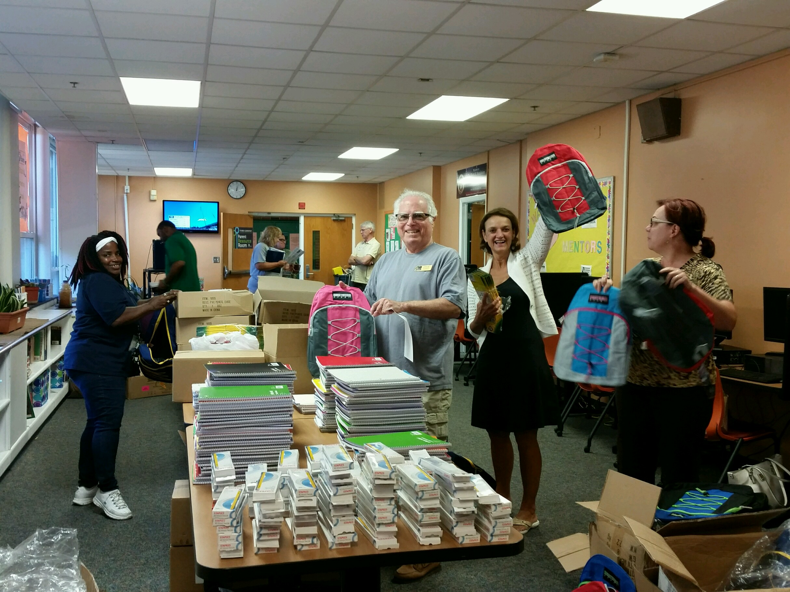 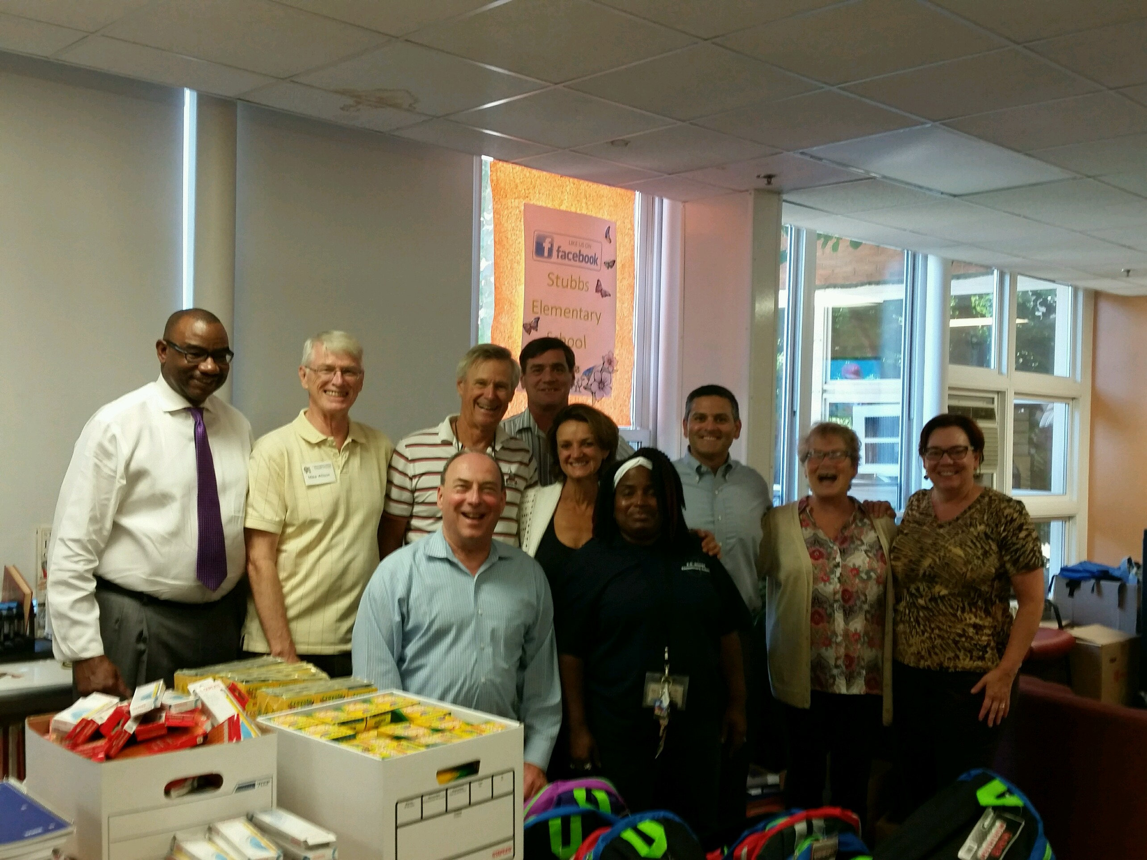 Karen(from Stubbs) Steve, Dori, Susan Lots & Lots of Back Packs Principal Jeffers Brown, Mike, Jon, Jon, Dori,
John, Sue, Susan, Dave, Karen

COME JOIN THE FUN TODAY
Back Pack Give Away & Community Back-to-School Party
Thursday, August 25th from 4-6 pm (park behind Stubbs Elementary)

Minutes for Meeting of August 18, 2016
President Kai Lassen called the meeting to order at 12:10pm at the Hotel du Pont. The Club joined together in singing “God Bless America” led by Jerry Bilton with Bob Reed on the piano. Cynthia Morgan provided the invocation.
Announcements: President Kai welcomed several visiting Rotarians and several more guests. President Kai then reported on the great activities last week around RI President John Germ’s visit to the area. He thanked and recognized all of our club members who attended one or more of those events. President Kai then gave a special “shout out” to thank David Greenblatt and his company, Office Movers, for storing many boxes of club files and for providing our Rotary office with new storage cabinets. President Kai then called upon Mike Wilson for the Stubbs Project Report. Mike reiterated that club members are needed for the backpack stuffing event on Tuesday, 8/23 from Noon – 2:00 PM and again next Thursday from 4:00 – 6:00 PM when those packs will be distributed to students. President Kai thanked Mike and Susan Polikoff for their leadership on this project. Jerry Bilton led us all in a rousing chorus of “In the Good ‘Ole Summertime” in honor of the 15th day above 90 degrees. Upcoming Meetings:
- August 25 – Adriana LaCorte & Pina De Rosa – Sniffing out cancer
- September 1 – Tim McDermott, Chief Business Officer, Philadelphia Union
- September 8 – Wilmington Mayoral joint appearance
- September 15 – District 7630 District Governor Clif Hutton
Program: Program Chair Roy Roper introduced our speaker’s table guests and out two guest speakers, Peggy Geisler, Project Director of the DCHI Healthy Neighborhoods Program and Julane Miller-Armbrister, Executive Director of the Delaware Center for Health Innovation. Julane started off by explaining that DCHI is working to ensure access to health care for everyone. It is an independent nonprofit organization whose mandate is to lead collaborative efforts to improve the health of Delawareans. Its goals are:
- For DE to become one of the top five healthiest states in the US
- To achieve top 10% performance for quality patient experiences
- Bring health care spending growth more closely aligned with growth of the economy
- PLUS ONE: achieve higher provider experience that leads to enhanced attraction/retention of health care professionals especially in specialties in which there is a chronic shortage – mental and dental health
Their efforts are dependent upon broad stakeholder participation across the full spectrum including health care agencies, large employers, advocacy groups, the business community, public officials and state/county agencies, health care providers and major educational institutions.
Among their initiatives is to replace the dozens of sometimes competing limited use scorecards with a single multi-tiered scorecard for service evaluation. Planning for this initiative began in 2011 and now, in 2016 the other initiatives are also being rolled out; 3 of the expected 10 “healthy neighborhoods”, enrollment of 50% or more of the private practices, scaling health care coordination, encouragement of consumers through outreach, and the start of various workforce strategies.
Peggy spoke in greater depth about the Healthy Neighborhoods concept that embraces 10 specific and logical geographic areas covering all of Delaware. This initiative is specifically to create tailored solutions in:
- Healthy lifestyles
- Maternal and child health
- Mental health
- Chronic illness prevention
They are currently engaging collaborators all across Delaware in these initiatives. The meeting ended at 1:30 pm. Both the Membership and the Public Relations committees held meetings this afternoon. Respectfully submitted, Acting Secretary, David W. Fleming
Bridgette Boody – Penn State Senior writes:
“I completed a fellowship immediately after finishing with finals and then began a technology free summer as a camp counselor in Lewes. The past year has been very busy for me, as I have juggled being a resident assistant with a part-time job, serving as a member of the Penn State Lion Ambassadors Student Alumni Corps, completing an internship, and participating in a pilot fellowship program in conjunction with the Georgetown University School of Law. Throughout it all, I have thoroughly enjoyed my classes, and my time at Penn State has been an incredible one. As I begin my senior year this week, I can’t help but think of how lucky I am to attend such an amazing university. It is because of your continued support that I have been able to have my dream college experience. Thank you again for your support.”

COMMITTEE MEETINGS / DATES / EVENT
August 25 Back Pack Giveaway & Community
Back-to-School Party, Stubbs School 4-6pm
September 1 Music, Public Relations, Rotary Information
September 8 International
RI President

