
The Rotary Club of Wilmington, Delaware
Celebrating over 100 Years of Fellowship and Service
ISSUE 18 2016-2017 NOVEMBER 10 – NOVEMBER 11
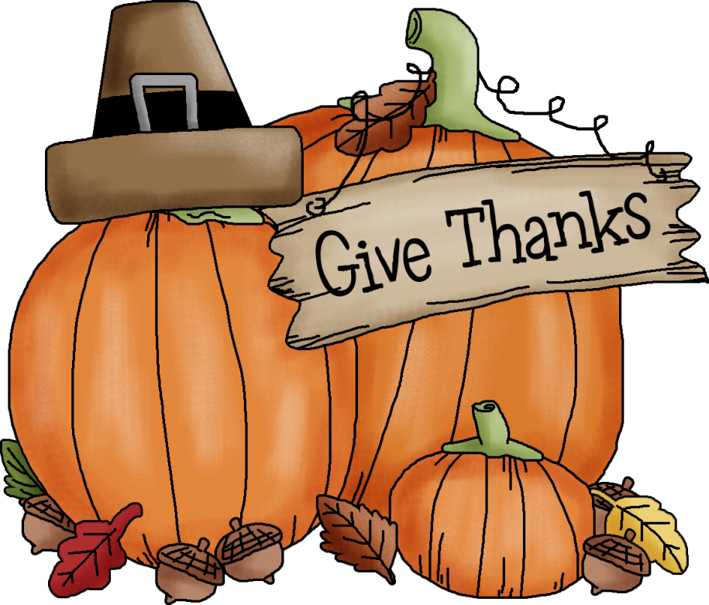
UPCOMING PROGRAMS
November 10
Lawrence Husick
Co-Chair, Center Study of Terrorism
Foreign Policy Research
Program Chair: Patrick Callahan
Menu: Baked Salmon with Champagne Mustard Cream Sauce

November 17 – Jeffry Cadorette, Rotary International Director Nominee for 2018-2020
“Why the Rotary Foundation?”
Program Chair: Elizabeth Rhoads
Menu: Teriyaki Glazed Flank Steak with Rice Pilaf
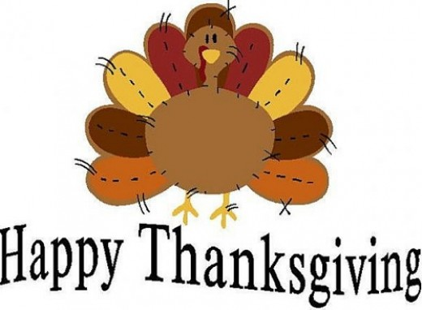
November 24 – NO MEETING
December 1 – Arreon Harley and the Cathedral Choir School of Delaware Performance
Program Chair: Norm Veasey
Menu: Filet of Flounder with Lemon Vin Blanc, Rice and Vegetable

December 8 - Holiday Party – Thursday, December 8 (No Meeting)
Delaware Center for the Contemporary Arts, Riverfront
Sign up and Details Available Next Week



Minutes for Meeting of November 3, 2016
President Kai Lassen called the meeting to order at 12:10pm at the Hotel du Pont’s du Barry Room. The Club joined together in singing the “God Bless America” led by Michael Arrington with Robert Reed on the piano. Neta Pringle provided the invocation. Announcements: President Kai moderated the following announcements: Elizabeth Rhodes – it’s the centennial anniversary of the Rotary International Foundation. Please consider becoming a sustaining member with an annual gift of $200 or a Paul Harris Fellow with an annual contribution of $1,000; President Kai – shared the following reminders: committee chairs please provide dates of meetings to Sue, the upcoming Foundation dinner, please get membership pledges in promptly, the club membership list is not to be used for publication to other organizations or shared with non-members, Howard HS is still collecting shoeboxes for sailors so please bring in your empty shoeboxes.
Program: Program chair David Fleming introduced the speaker, our fellow Rotarian, David Cole, Executive Director of Hagley Museum. David sharied a brief overview of the history of Hagley since its founding in 1802 and a review of the museum’s campus. He noted that what he most wanted to share was the recent addition of the collection of U.S. Patent Models to the museum’s assets. He provided a brief history of the U.S. Patent Office, noting that when the Patent Act was first written by Thomas Jefferson and passed into law, it required that, in addition to the submission of drawings and specs, inventors were required to also submit a mini-model of their invention that could be no larger than 12” x 12” x 12”. The models were all labeled with a tag attached by a red tape-like ribbon – thus the origin of phrases “tied up in red tape” and “cut through red tape.” The Patent Act also noted that no patents would be examined for infringement, but that the courts would decide.
The patent office was first housed in Blodgett’s Hotel and was quickly overrun by the number of patent submissions. In 1834, Congress revised the Patent Act to require the U.S. Patent Office to examine submissions for infringement and to build a new building. In 1836, the new building burned and every patent submitted from 1790-1836 was lost. From 1836-1871 Congress built a new building in phases, which is now known as the home of the Smithsonian National History Museum and Portrait Gallery. By 1870 over 300,000 patents and their models were stored in the building and hundreds of patent examiners were employed. The facility was open to the public, who could view the patent models in enclosed glass cases. Over 100,000 people came each year to visit and it was called The National Gallery. David noted that an overwhelming majority of patent submissions did not have commercial success and most names were lost to history, but a few were famous – a carpet sweeper submitted by Melvin Bissell and a rubber patent submitted by Nelson Goodyear, in particular. In 1877, The National Gallery experienced another fire and approximately 112,000 models were lost, but over 250,000 survived. By the 1870s and 1880s, the Patent Office was so overwhelmed by the number of submissions, that the models needed to be stored offsite. By the 1890s models were no longer required for submission, but they still came. By the 1900s models were no longer permitted to be sent and any submitted with a model were rejected. During Herbert Hoover’s administration, the decision was made to auction off the patent models. Most were purchased for scrap, some were purchased by collectors and the Smithsonian received fewer than 10,000 of the models. Throughout the 20th Century, collectors tried to aggregate the models to create a National Museum of U.S. Invention, but did not succeed. In 2015, collectors Alan and Ann Rothschild, who spent 25 years collecting 5,000 models, gifted their collection to the Hagley Museum after turning down offers from museums around the world. Now Hagley has a number on display in the museum, will be creating a permanent rotating exhibit in the visitor’s center and will be creating a touring exhibit that is set to visit four cities in China in 2017. The meeting ended at 1:30 pm. Respectfully submitted, Carrie Gray, Acting Secretary
SALVATION ARMY BELL RINGING
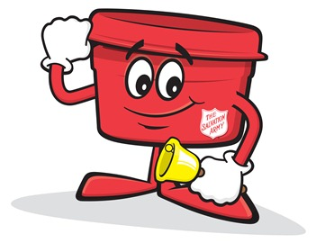
MONDAY, DECEMBER 5 THROUGH FRIDAY, DECEMBER 16
SIGN UP AT MEETING OR WITH SUE

If you play a brass instrument typically found in a brass ensemble like the trumpet, trombone, tuba,etc., please consider joining our Rotary Holiday Brass Ensemble that will be performing in mid-December. For more information, please contact one of the following: Marv Andersen (mva2006@verizon.net)
Bill Holloway (holloway@bernardon.com) Bob Reed robertlaytonreed@comcast.net)
COMMITTEE MEETINGS / DATES / EVENTS
November 19 Rotary Foundation Dinner, Dover, 5:30pm
November 22 Nomination Committee
November 23 Board Meetng
November 24 Happy Thanksgiving - NO Meeting
December 8 Annual Holiday Party, DCCA, Riverfront
December 28 Board Meeting
December 22 NO Meeting – Happy Holidays
December 29 NO Meeting – Happy New Year 2017

