Ashley Cloud
From: Ashley Cloud
Sent: Mon, 31 Jan 2022 16:01:21 +0000
Bcc: Allison T. Levine (alevine@delcf.org); Amy Bielicki (Amy.Bielicki@ChristianaCare.org); Andrew Johnson(AJohnson@coverrossiter.com); Anne Eidschun (Anne.Eidschun@griswoldhomecare.com); Atul Chugh; Audrey Boys (Audrey.Boys@me.com); Basile Njei(basilenjei@gmail.com); Bill Holloway (holloway@bernardon.com); Bill Jensen; Bill Medford (wmed4@aol.com); BillyLane(cgmalliswell@verizon.net); Bob Reed; BrandonBrice(bbrice@uwde.org); Brenda Romeus(BrendaR@kwcommercial.com); Bruce Swayze (bswayze@wscins.com); Buck Smith (HCSVette@aol.com); Cam Yorkston (yorkstonconsulting@comcast.net); Caroline Jones (carolinejones@kindtokids.org); CarrieGray(carriewgray@hotmail.com); Catrina Jefferson (catrina.jefferson@cscglobal.com); Charles Elson(charlesm_elson@comcast.net); Charley Broll (cbroll@aol.com); Charlie McDowell (cmcdowell@potteranderson.com); Chris Daney; Christian.Ian.Bale@gmail.com; Cindy Campanella(CCampanella@bancroftusa.com); Cynthia Morgan (cynthiaperspective@gmail.com); Dave Fleming(flemingdw67@gmail.com); DaveSchaen(DavidLSchaen@icloud.com); David DeVoll (david.devoll@yahoo.com); David Rhoads (dgrhoads@dgrhoads.us); David Woods (David.Woods@delautism.org); David Young(dyoung@dehistory.org); Deborah Bagatta-Bowles (dbowles@ymcade.org); Donald Parsons (dfparsons2@gmail.com); Dori Jacobson (dorijacobson@mac.com); Elizabeth A. L. Rhoads (erhoads@dgrhoads.us); Norm Veasey (eveasey@gfmlaw.com); Robert Katzenstein; Robert Reardon (rreardon66@gmail.com); FrederickEbede(admediade@yahoo.com); Gene Julian (eugene.julian@comcast.net); George Alderman (galderman32@comcast.net); Gil and Alice Smith (agsjr@verizon.net); Gina Kennedy(gkennedy@che-east.org); Giovanni P. Conigliaro (giovanni@nsolutionist.com); GregBallance (gballance@diamondtechnologies.com); Guillermina Gonzalez (contactguille@comcast.net); HeatherMorrissey(HMorrissey@delart.org0; Ian R. McConnel (Ian.McConnel@cscglobal.com); Jaime Wills; JakabcinKathryn (KJakabcin@ycst.com); Jane C. W. Vincent (jcvincent@gmail.com); Jean G. Dahlgren (president@dcad.edu); Jerry Bilton (JABilton@aol.com); Jim Ellison (james.m.ellison@christianacare.org); Jim Lee(jlee@stratfi.com); Joan DelFattore (jdel@udel.edu); Joan Hoge-North(jhoge-north@delcf.org); Joan Sharp; Joe Melloy (jmelloy@msn.com); John B. Morton Jr. (jbm42@msn.com); John Jornlin (jjornlin@wilmingtontrust.com); John Matarese (JMatarese@wsfsbank.com); John Newlin(middlemadness@gmail.com); John Potter (john.d.potter@verizon.net); John S. Cigler (jcigler@cbhinc.org); Jonathan Diamond (jonathandiamond33@hotmail.com); Jonathan Hickey (jonhickey@emoryhill.com); Joseph E. Carbonell (joecarbonell3@gmail.com); Joseph Setting (joe@setting.com); Julia Bettin Klein(klein@kleinllc.com); KaiLassen(Kailassen@gmail.com); Karen Kegelman(kkegelman@choirschoolofdelaware.org); Kate Cowperthwait (cowperthwaitkate@gmail.com); Ken Grant(kgrant@aaamidatlantic.com); Ken Sklenar (ksklenar@esdel.org); Kevin Smith (klsmith@habitatncc.org); Larry Gehrke (lgehrke845@aol.com); Larry Zutz (lawrence.zutz@usi.biz); Lisa Detwiler:ldetwiler@ssdel.com; LisaMore (lisamore96@icloud.com); Lossie Freeman (lossiefreeman@googlemail.com); Lynn Jones (lynncjones77@gmail.com); Madeleine Bayard (mbayard@rodelfoundationde.org); MargiPrueitt(m.h.prueitt@gmail.com); Marsha Borin (mborin@comcast.net); Martha Gilman (marthag@gildevco.com); Mary Jo Anderson (andersmj44@gmail.com); MATT BEARDWOOD; Matt Brown; Matt Urban (murban@nupointmarketing.com); Michele Anstine(MAnstine@dehumanities.org); Mike Kelly (mkelly@mccarter.com); Mike Staman(Michael.Staman@schwab.com); Murray Sawyer (hms@WestoverCapital.com); Peg Laird (peglaird@me.com); David Harrison(dharrisononleave@gmail.com); MaryChan(nahcyram@gmail.com); NancyBlumberg(nbjb4@comcast.net); Neta Pringle (npringle@msn.com); Nicki Pickles (npickles@cscde.org); Noel Burnham (nburnham1234@gmail.com); Pam Cornforth (Pam Cornforth); Patrice Gilliam Johnson (pgjohnson@desu.edu); patricia@trinityparishde.org; Paul L. Bechly (paul.bechly@morganstanley.com); PeggyAbleman(placourtlyme@yahoo.com); Pete Booker (peteb81151@gmail.com); PeterHorty@aol.com; PhilipForkpa(philipforkpa2007@yahool); Ralph D. Marshall (rmarshall@wilmingtonfinancial.com); Ranney Ward (PW19807@comcast.net); Rich Williams (rlwilliams@ashland.com); Richard Flanagan (rdf3131@verizon.net); Richard J. Gessner (rjgessner@hotmail.com); Richard Paverd - ICT LLC (rpaverd@inttec.com); Richard Stat [RStat@statorganization.com]; Robert Martinelli (rmartinelli@todaymediainc.com); Robert McCoy(rcmccoy@me.com); Rosalyn Keesee(rosalynk@dciarchitects.com); RyanRose(ryan.rose@foxroach.com); santiagorojascarbonell@gmail.com; Sam Waltz (SamWaltz@SamWaltz.com); Samantha Diedrick; SamuelMoultrie(moultries@gtlaw.com); Sheila Bravo (sbravo@delawarenonprofit.org); Stanley Diver (smd@diverandassociates.com); Steve Novack (Steve.novack@comcast.net); Sue Knisely; Ted Geist (Eggeist1@gmail.com); Thorpe Moeckel; Tim Lyons (tlyons@lyonsinsurance.com); Tom Henderer (thenderer@comcast.net); Tom Shea (tshea@marycampbellcenter.org); Tom Smith(tdsmith@visitingangels.com); Tucker Robbins(tucker@robbinsrealestate.com); VinceEpiscopo(vepiscopo@ncall.org); Warren Du Pree(warrendupree@yahoo.com); Wil Sherk; Will Minster (wjminster@gmail.com); Yair D. Robinson (rabbirobinson@bethemethde.org)
Subject: Rotary News & Notes - 2.3.22 Speaker Ashley B. Cloud- "Last Stop to Freedom on the UGRR"
Good Morning!

Last Monday, I shared The Four-Way Test on Facebook. I took the time to research its origin (1932, Rotarian Herbert J. Taylor) and to reflect on its meaning. I find it telling that this simple, yet profound sentiment has found its way into popular consciousness, interpreted in a way that our children can understand. A startling yet reassuring revelation at the depth, breadth, and positivity of Rotarian influence.



This week’s featured speaker:

Ashley B. Cloud – former Executive Director of the Quaker Hill Historic Preservation Foundation

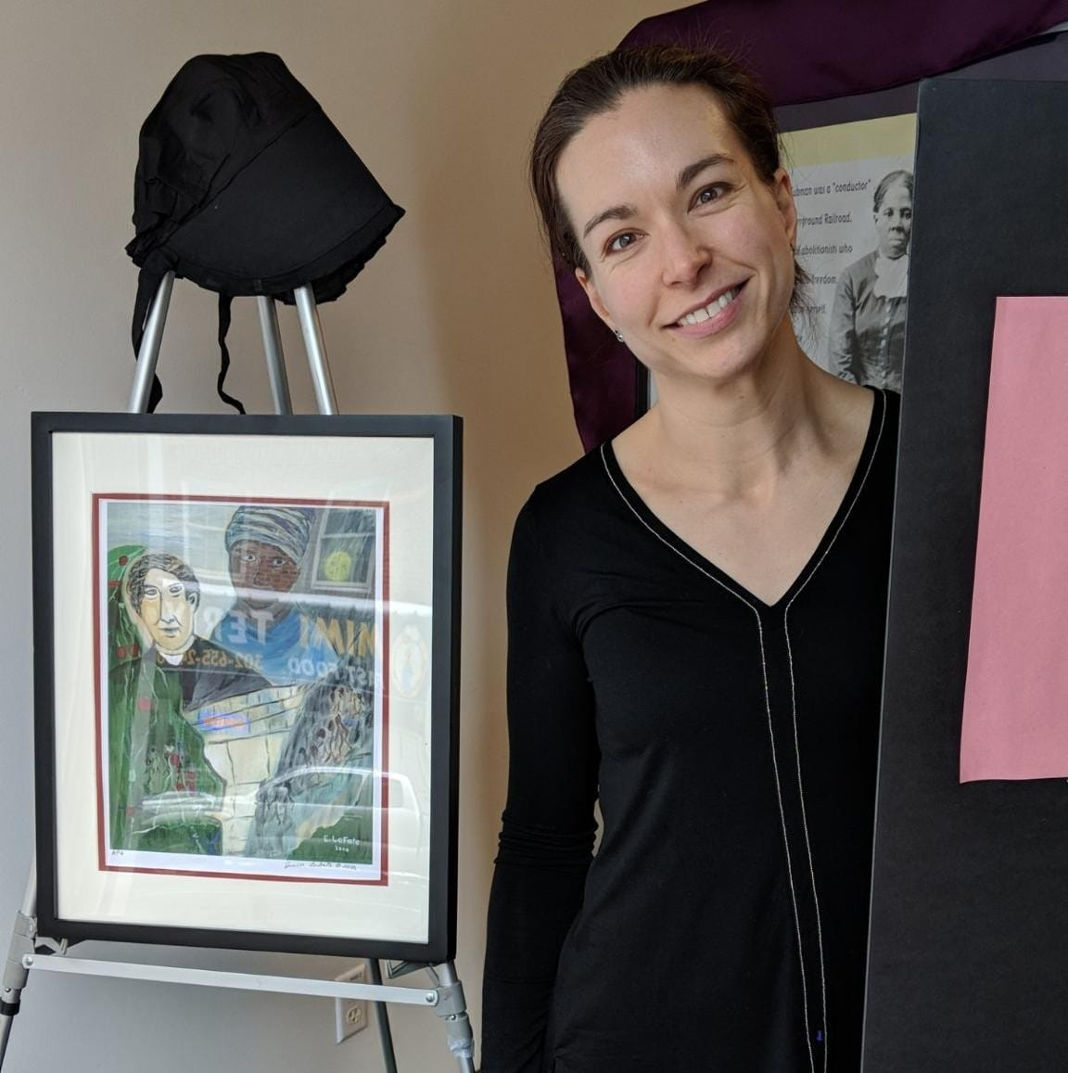

Wilmington’s role as the “Last Stop to Freedom” on the Underground Railroad

Zoom link: https://us02web.zoom.us/j/7972453263

Meeting ID/Passcode: 797 245 3263

Manual Dial-in: (646) 558-8656

IMPORTANT Date Change

The “Our Path Forward” planning session has been rescheduled for Thursday March 10th please update your calendars accordingly

Program Committee Meeting 2/3

Committee members and interested Rotarians are encouraged to remain on this week’s Zoom call for a Program Committee meeting immediately following the end of our weekly meeting

Have you met your 2021-2022 Club Officers?

The RCW has survived and thrived thanks to the hard work and dedication of its officers. They have truly risen to the challenge and helped the Club navigate uncharted waters. Let’s take a moment to recognize them:

President: Wilfred B. Sherk
President-Elect: Jonathan R. Hickey
Immediate Past President: Amy K. Bielicki
Secretary: David W. Young
Assistant Secretary: Tucker Robbins
Treasurer: Michael Staman
Assistant Treasurer: Sheila Bravo

Directors
Atul Chugh
Lynn C. Jones
Robert L. Reed
Madeleine Bayard
Ken Grant
Samuel L. Waltz

Thank you,

Ashley
Ashley B. Cloud
Rotary Executive

Rotary Club of Wilmington
Community Service Building
100 W 10th Street Suite 1006 Wilmington, DE 19801
PO Box 685 Wilmington, DE 19899
Phone: 302.655.6025 | office@rotarywilmington.org


