
The Rotary Club of Wilmington, Delaware
Celebrating over 100 Years of Fellowship and Service
ISSUE 16 2016-2017 OCTOBER 27 – NOVEMBER 3

UPCOMING PROGRAMS

October 27
Rotary Club of Wilmington
2016-17 Community Service Project
Stubbs Elementary School
Speakers: Jeffers Brown, Ken Livingston
Program Chair: Susan Polikoff
Menu: Brown Sugar Baked Ham with Glazed Yams
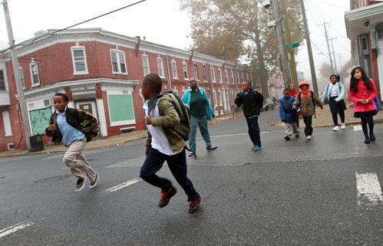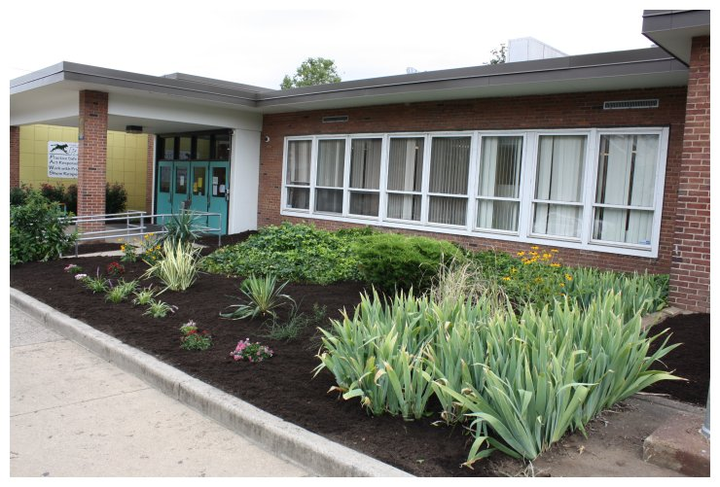
Wilmington Rotary is partnering with Stubbs Elementary School this year to help the school and its students in a number of ways: in education, nutrition and well-being, and providing fun events for the kids. Among our hands-on projects for Stubbs are supporting high-protein breakfasts, organizing Thanksgiving meals for families of the students, providing school uniforms, contributing to its furniture collection for families with home needs, helping prepare and distribute backpacks for its students, distributing Gazetteer dictionaries, supporting its chess initiative, replanting its Secret Garden, and mentoring. Additionally, we will be filling Holiday stockings for all its students. This is an opportunity for all Rotary members to provide hands-on help.

November 3 – David A. Cole, Executive Director, Hagley Museum & Library-du Barry Room
“Tales of Innovation: Highlights from the Collection of the Hagley Museum and Library"
Program Chair: David Fleming
Menu: Roasted Turkey with Stuffing, Green Beans and Mashed Potatoes
November 10 – Lawrence Husick, Co-Chair
Center Study of Terrorism, Foreign Policy Research
Program Chair: TBD
Menu: Baked Salmon with Champagne Mustard Cream Sauce
November 17 – Jeffrey Cadorette, Rotary International
Rotary International Centennial Celebration
Program Chair: Elizabeth Rhoads
Menu: Teriyaki Glazed Flank Steak with Rice Pilaf

Minutes for Meeting of October 20, 2016
President Kai Lassen called the meeting to order at 12:10pm at the Hotel du Pont’s Gold Ballroom. The Club joined together in singing the “Star Spangled Banner” led by Jerry Bilton with Anne Eidschun on the piano. Rich Williams provided the invocation.
Announcements: President Kai welcomed several guests. President Kai called on Yasser Payne, who introduced our newest club member, Kia Ervin – welcome, Kia! President Kai called on numerous club members who made the following announcements: Mike Wilson – thank you to our over 50 volunteers (members and families) from Wilmington Rotary who joined other Rotary volunteers in supporting Stop Hunger Now, Saturday, October 15. A total of 34,560 meals were packed to be distributed worldwide. A slideshow of pictures from the event was shown prior to commencement of today’s meeting; President Kai mentioned that we have multiple hands-on activities scheduled this year and please participate in at least one event as they are fun and engaging; President Kai – there is one opening for Rotary Leadership Institute on Saturday, October 22nd, please contact Sue if you are interested and we have 8 members attending; Elizabeth Rhoads – since its inception in 1917, the Rotary Foundation has raised over $1 billion and our club has contribute $971,649. If each club member contributes $142, this will bring our contribution to $1 million, which would be wonderful to achieve this milestone for the centennial anniversary. Special thanks to the following Paul Harris Fellow recipients Anne Eidschun (PHF +6) and Richard Stat (PHF +5); President Kai – we have a 20% response rate for pledge cards returned for the Charitable Contribution Campaign. An average gift of $300 per person would provide tremendous support for our initiatives planned for our club; Tim Lyons – Thank you to the ~ 20 Rotarians and guests who attended “Coffee Talk” yesterday at the Greenville Brew HaHa! There will be more opportunities like this announced soon; Meredith McAloon – 25 tickets are available for the 87’ers basketball outing on Saturday, November 12th at the University of Delaware. Tickets are $14 each, doors open at 6:00pm, and tip-off is at 7:00pm.
Program: Matt Beardwood provided the introduction of the speaker, John Aucott, Director, Lyme Disease Research Center, Johns Hopkins Division of Rheumatology. John’s presentation was titled ‘Lyme Disease: An Unfinished Puzzle,’ and he offered his perspective on this century old diagnosed disease. Lyme disease is a bacterial infection primarily carried through ticks. There are 329,000 newly diagnosed cases each year in the United States. While cases are reported worldwide, there are no documented cases every reported from the state of Hawaii or the continent of Antarctica. It is the second largest infectious disease in the United States and New Castle County, Delaware ranks in the top 10 counties in the US for reported cases each year. It’s most effectively treated within the first 2-4 weeks of infection and delayed treatment can cause a myriad of unwelcome and serious side effects in humans that can last many years. Lyme disease was discovered approximately 100 years ago and it was officially named Lyme disease in 1977 when many cases where discovered in Lyme, Connecticut. It was originally treated as a virus. Fortunately, a physician visiting the United States from Sweden shared that Sweden treated this disease as a bacterial infection, which assisted the United States with changing its approach to treating the disease. A medical entomologist named Dr. Burgdorfer started to examine ticks in the 1980’s and he discovered bacteria in ticks that was transmitted to humans. This bacteria was named Borrelia and it is detectable in human blood which is useful in diagnosing the disease.
John shared a concept called Defining Failure of Treatment. He said early detection and treatment is ideal. Sometimes treatment is delayed or people can be misdiagnosed and this can result in long term unpleasant or debilitating side effects (i.e. neurological, muscular, skeletal, headache, fatigue, pain). This is called Post Treatment Lyme Disease Syndrome or Chronic Lyme Disease and it is very real even though people will discount this.
Detecting this disease is like finding a needle in a haystack because it does not act like typical bacteria. It can’t be cultured, there is no vaccine, and can only be detected in the blood at the early stages of infection. Unfortunately, the disease can trigger other autoimmune diseases in infected humans later in life. John shared that the Lyme Disease Research Center was thrilled to partner with Johns Hopkins University in 2015 and the Center has 25 national collaborators who continue to research the disease in the hopes of treating Lyme disease more effectively and finding a permanent cure. The meeting ended at 1:30 pm. Respectfully submitted, Cindy Campanella, Secretary

Delaware 87ers (Phila 76ers) vs. Westchester Knicks (NY Knicks)
COMMITTEE MEETINGS / DATES / EVENTS
October 27 International, Program, Rotary Foundation
November 12 Family Fun, 87ers, UofD, 6pm
November 19 Rotary Foundation Dinner, Dover, 5:30pm
November 22 Nomination Committee
November 24 Happy Thanksgiving - No Meeting
December 8 Annual Holiday Party, DCCA, Riverfront

SATURDAY, NOVEMBER 12 – ROTARY BLOCK OF SEATS $14/ticket
Bob Carpenter Center, UofD, Newark
7:00 pm Tip-Off
Doors Open 6:00 pm
FREE Kids Zone w/Moon Bounces, Face Painting, Legos & More!!
Opportunity to “High Five” Players as They Go on the Court!!!

