
The Rotary Club of Wilmington, Delaware
Celebrating over 100 Years of Fellowship and Service
ISSUE 29 2016-2017 FEBRUARY 23 - MARCH 2
UPCOMING PROGRAMS
February 23
Brendan Kennealey, President
Salesianum School
Program Chair: Anne Eidschun
Menu: Baked Meatloaf with Spinach & Cheese, Brown Mushroom Sauce

March 2 – Sam Beard, Founder, GIFT
Program Chair: Joan DelFattore
Menu: Lasagna Roulades

March 9 – Tory Dobrin, Director, Les Ballets Trockadero de Monte Carlo
The World’s Foremost All-Male Comic Ballet Company
Program Chair: Marsha Borin
Menu: Chicken Breast with Sweet Chile Glaze

March 16 – Jeff Downing, Executive Director, Mt. Cuba Center
“Mt. Cuba Center, a Jewel of the Brandywine Valley”
Program Chair: Pam Sapko
Menu: Corned Beef and Cabbage, Au Gratin Potatoes


Mulch Madness
Saturday, March 18 ** 8:30 – 10:30 am
A great project – A great time – A great way to serve
Sign Up in Lobby or with Sue


You are cordially invited by members of the
Wilmington Strategy Committee
to attend WSC Dialogues
Thursday, March 23, 2017 from 5:30pm to 7:00pm
at the home of Su and Peter Horty, 53 Hill Road, Wilmington 19806
Topic: “It’s set up for failure . . . and they know this!”
How the school-to-prison pipeline impacts the educational experiences
of street-identified Black youth and young adults
Presenter: Rotarian Yasser Payne
WWC Dialogues are intended to be both social and educational in nature,
offering members a forum in which to talk about current issues affecting the City of Wilmington, our local community, and what our Rotary Club hopes to do to help.
After the topic has been presented, questions and idea sharing will be welcomed.
Wine and cheese will be served and space for this event is limited to 20 people
Kindly sign-up at meeting or email Sue Hastings at office@rotarywilmington.org before March 16

Minutes for Meeting of February 16, 2017
President Kai Lassen called the meeting to order at 12:10pm at the Hotel du Pont’s du
Barry Room. The Club joined together in singing the “Battle Hymn of the Republic” led by Carrie Gray accompanied by Bob Reed on the piano. Jim Wilson provided the invocation.
Announcements: President Kai made the following announcements – Club member Tim Lyons is recovering from a Lyme’s Disease setback so please sign the card that is circulating; Contributions to our Scholarship Fund in memory of Audrey Hatfield have reached over $11,000; and the Office will be closed on Monday, February 20 in observance of Presidents’ Day; Sarah Brown – introduced new member, Lossie Freeman – welcome, Lossie!; Tom Shea – provided PHF & PHS presentations as follows: PHF – Bill Holloway, Bob Katzenstein, Hughlett Kirby, and Tom Porth; and PHS – Ellie Corbett Hannum, Bruce Swayze, and Rod Teeple. Our club currently has 23 members in the PHS and thanks to all for their continued support; and Rosi Crosby – provided a presentation on the Sindh Desert on behalf of the International Committee.
Program: Dave Fleming provided the introduction of the head table and our speaker, Stuart Comstock-Gay, President and CEO of the Delaware Community Foundation. Stuart’s presentation, titled ‘For Good and For Ever – Delaware Community Foundation and the Delaware Legacy’ was a stellar overview of the Delaware Community Foundation.
Founded in 1986, the Delaware Community Foundation helps communities and philanthropists focus charitable resources for the greatest community benefit statewide. Their mission is to build a shared vision for Delaware, grounded in knowledge, inspired by the common good and advanced through philanthropy. They see their vision as thriving, vibrant communities, driven by collaborations that unite generosity, knowledge and other resources to address Delaware’s evolving needs and opportunities. For more information, please visit https://delcf.org/.
Stuart shared two fundamentals goals that are core to their work, which is to improve the quality of life through the ability to empower and celebrate giving and to engage with communities. He also shared information from their recent initiative, Delaware Focus, which provides a data and content overview of the State of Delaware in the following seven categories: Children & Youth, Demographics, Economy & Workforce, Education, Financial Well-being, Health, and Community Life. For more information on this incredible website, please visit http://www.delawarefocus.org/. Now that this website is complete, it can be used to tell a story and identify opportunities where the Delaware Community Foundation’s resources can be most useful.
Stuart closed with saying that as a result of the partnerships with generous philanthropists and communities, we are better together! The meeting ended at 1:30 pm. Respectfully submitted, Cindy Campanella, Secretary

BOARD OF DIRECTORS MEETING ** FEBRUARY 22, 2017
HOWARD HIGH SCHOOL OF TECHNOLOGY
CULINARY SCHOOL

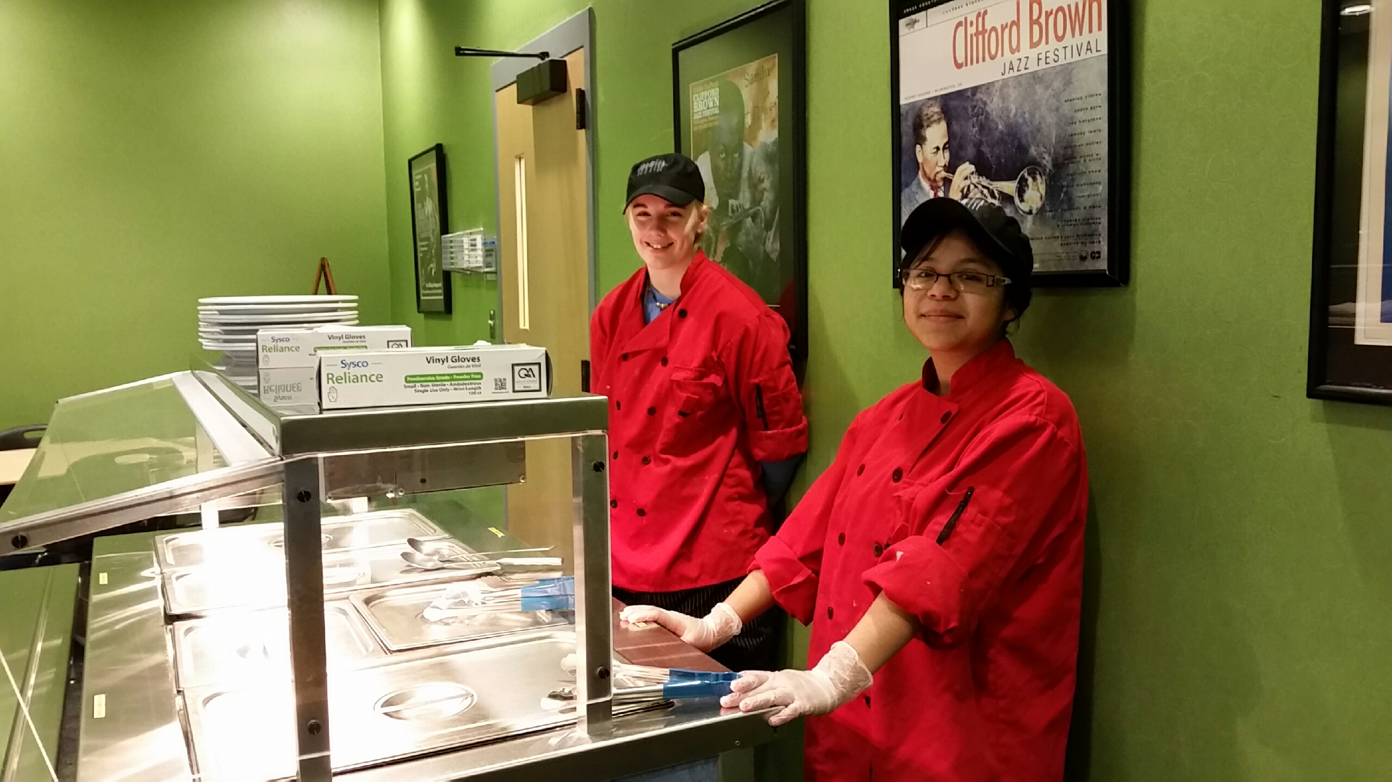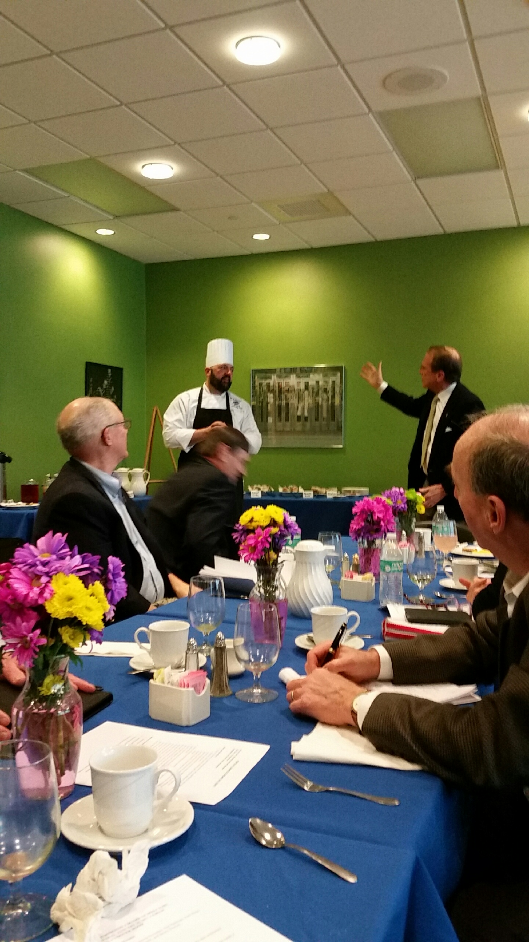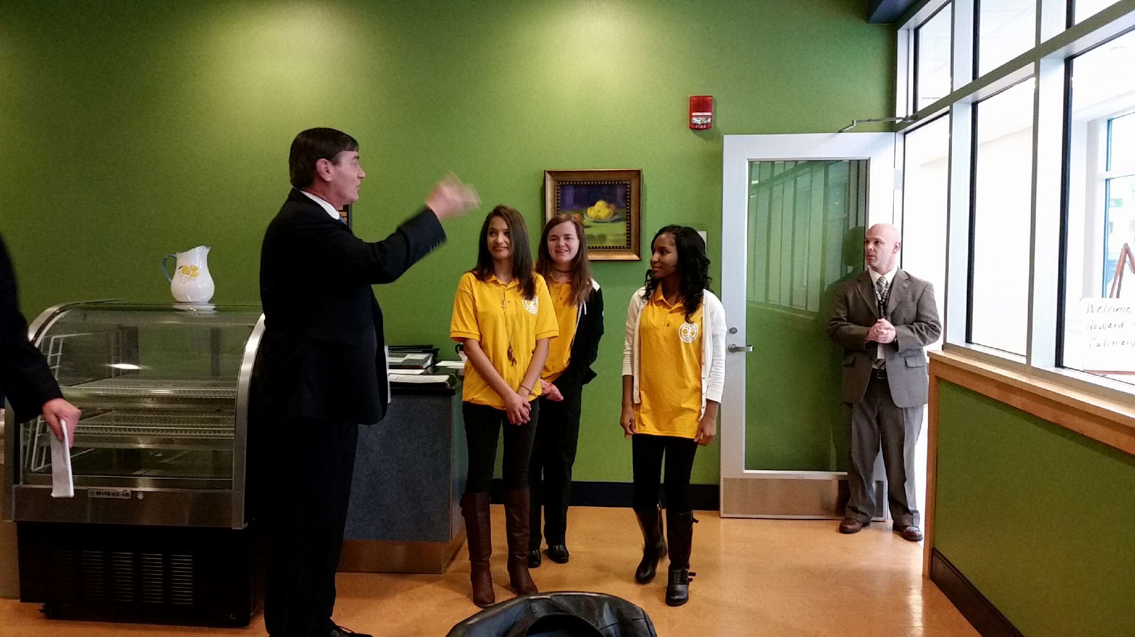
Culinary Students Prepare and Serve President Kai introduces the Jon Whitcomb, Interactors and
a Delicious Breakfast Chef who oversees students Principal Stanley Spoor Share Ideas

COMMITTEE MEETINGS / DATES / EVENTS
Mar 18 Can-Do Playground Clean Up, 8:30-10:30 am
April 21-22 Camp Fairlee Clean Up
April 22 RLI, Maple Dale CC, Dover, DE, Registration 8:00am
April 27-30 District Conference, Dover Downs, Dover, DE
May 19 Camp Fairlee Campaign Celebration
May 23 President-Elect Samantha Diedrick Club Assembly, WCC
June 10-14 RI International Convention, Atlanta, GA

