
The Rotary Club of Wilmington, Delaware
Celebrating over 100 Years of Fellowship and Service
ISSUE 28 2016-2017 FEBRUARY 16 - FEBRUARY 23
UPCOMING PROGRAMS
February 16
Stuart Comstock-Gay, President & CEO
Delaware Community Foundation
“For Good and For Ever -
Delaware Community Foundation and the Delaware Legacy”
Program Chair: Dave Fleming
Menu: Seafood Stuffed Flounder with Old Bay Cream Sauce

February 23 – Brendan Kennealey, President, Salesianum School
Program Chair: Anne Eidschun
Menu: Baked Meatloaf with Spinach & Cheese, Brown Mushroom Sauce

March 2 – Sam Beard, Founder, GIFT
Program Chair: Joan DelFattore
Menu: Lasagna Roulades

March 9 – Tory Dobrin, Director, Les Ballets Trockadero de Monte Carlo
The World’s Foremost All-Male Comic Ballet Company
Program Chair: Marsha Borin
Menu: Chicken Breast with Sweet Chile Glaze


WELCOME TO OUR NEWEST MEMBER ***** LOSSIE FREEMAN
Proposer: Sarah Brown Seconders: Ajit George & Joan Sharp
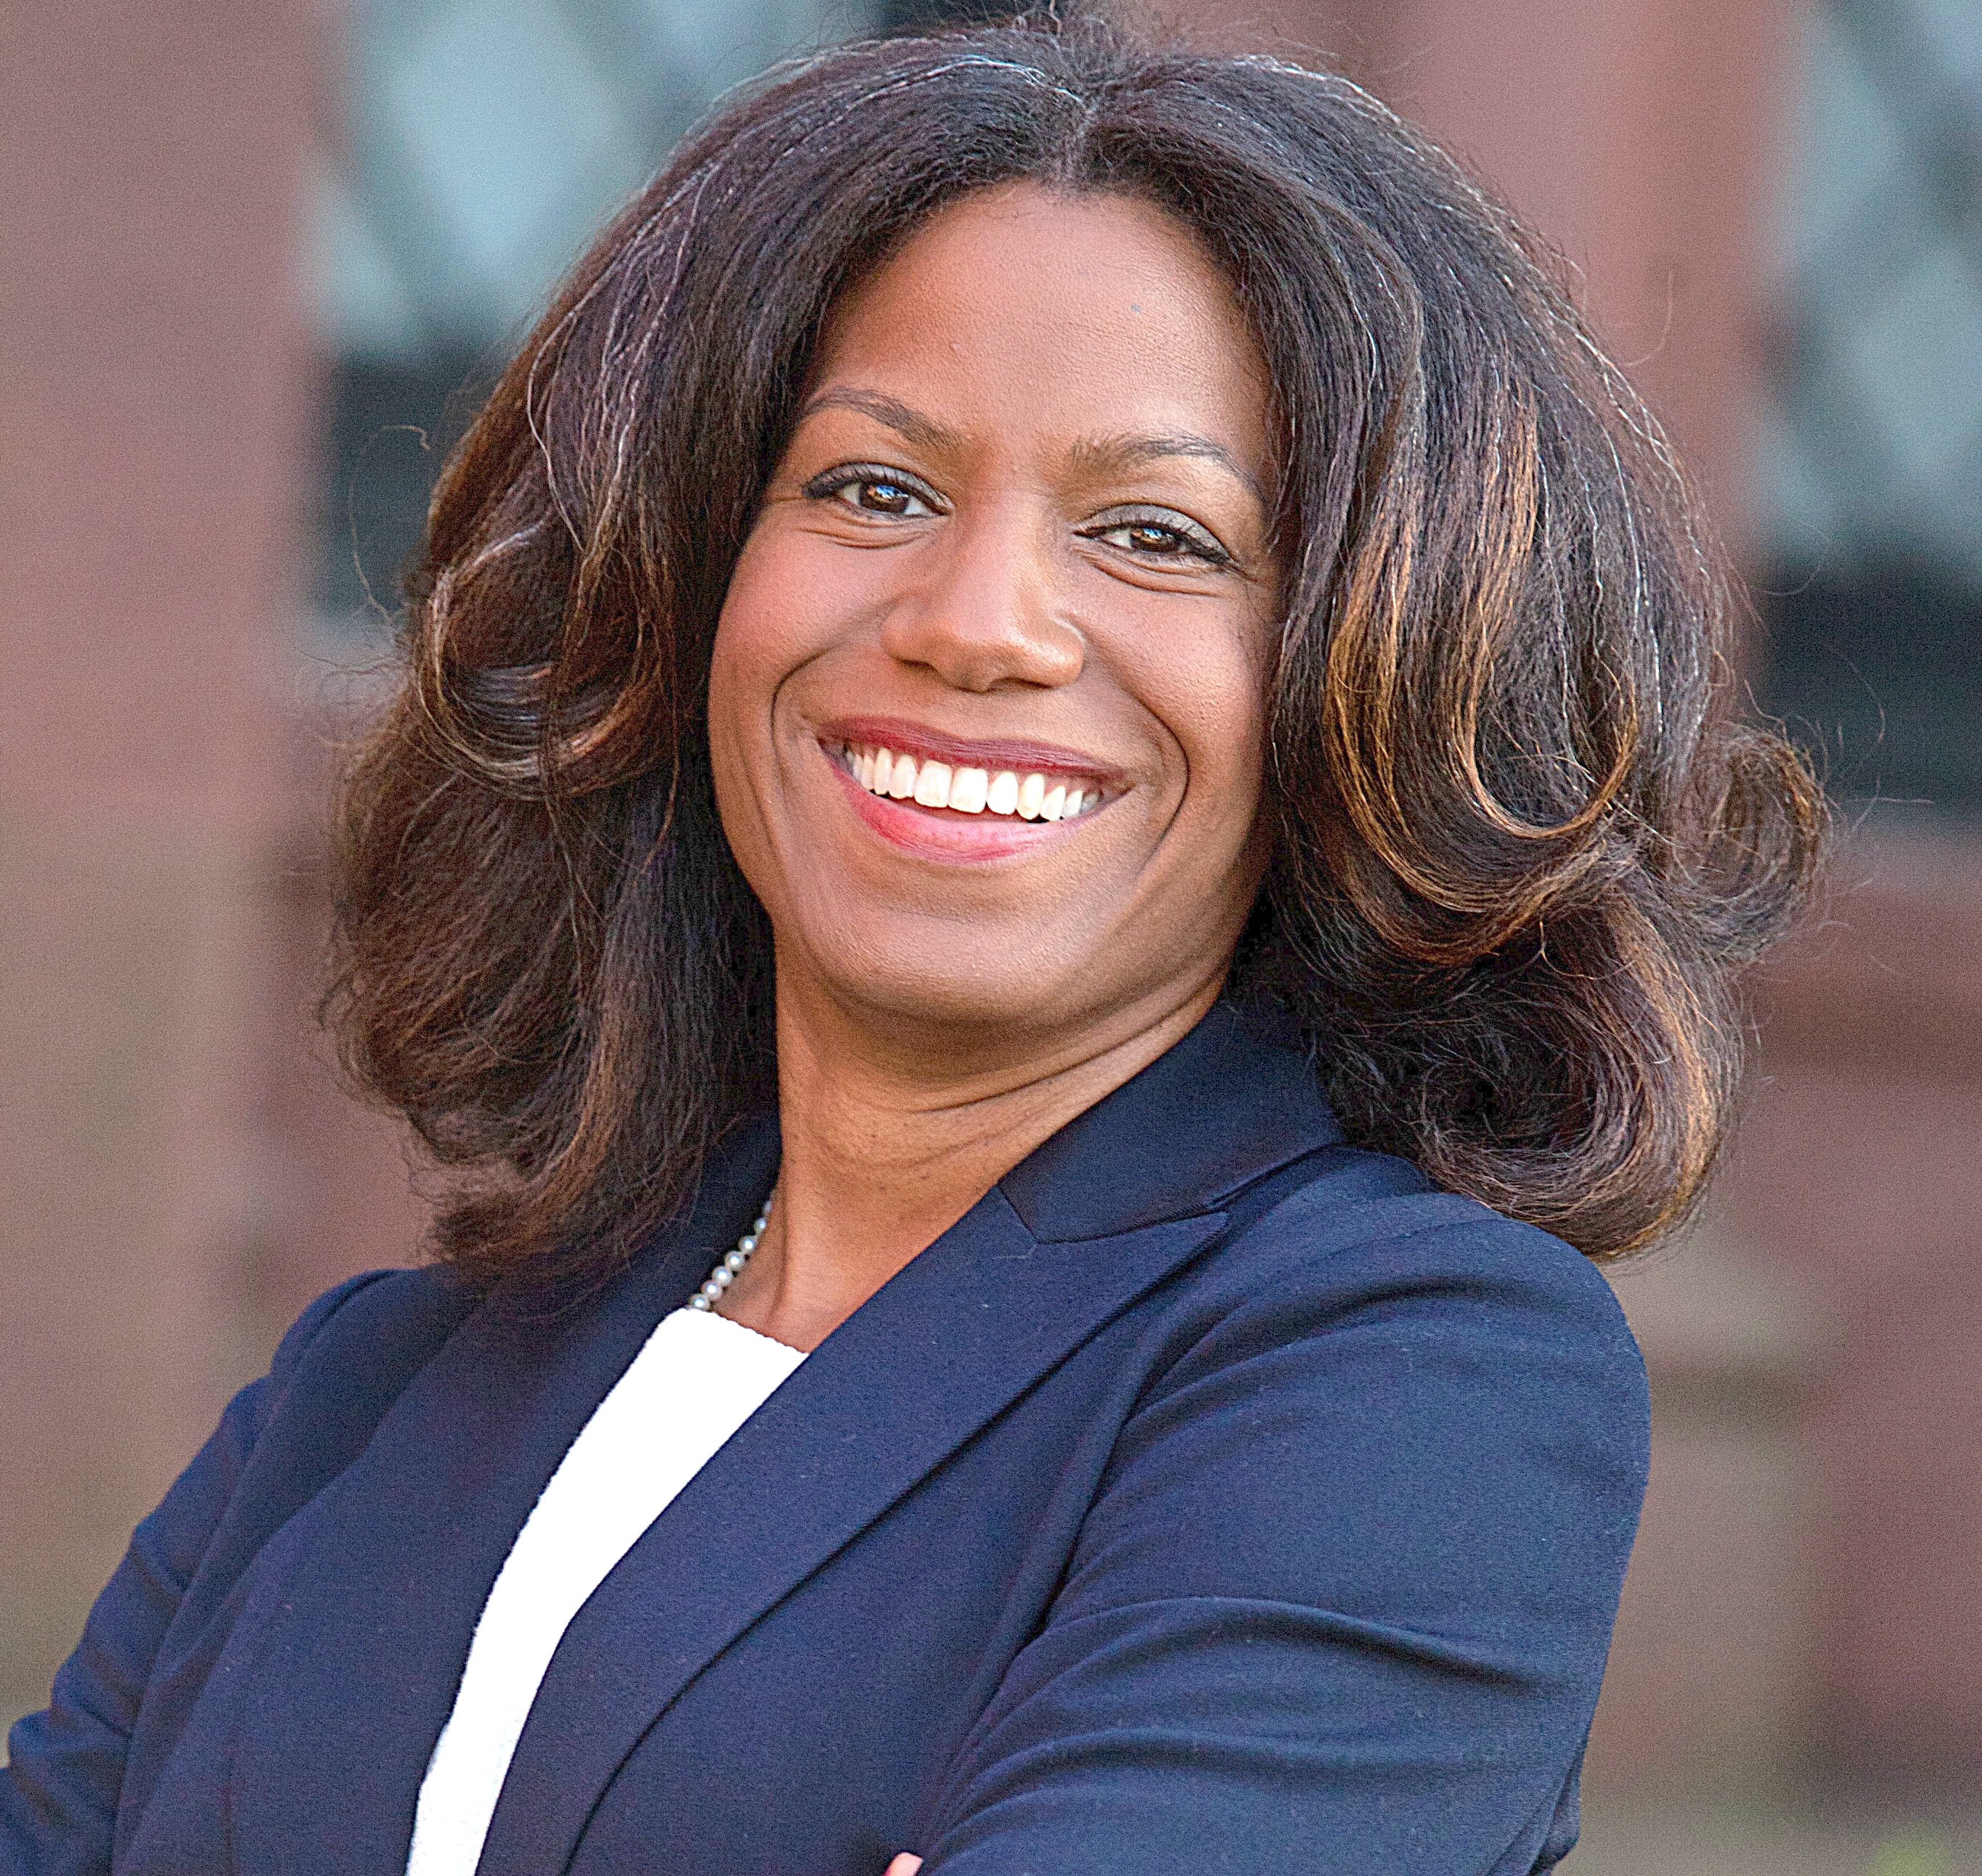
Lossie works as a Special Assistant to Mayor Purzycki for Employment Initiatives to coordinate the administration’s efforts to develop an employment infrastructure, in partnership with the business community, to promote job creation, identify job skills, training opportunities and to advance the recruitment and placement of our unemployed citizens. Lossie began her career on Wall Street JPMorgan as an Internal Global Consultant. She holds a B.A. in Economics from Salem College and an M.P.A. in Economic Policy Management from Columbia University’s School of International and Public Affairs. Her interests include: Economic Development and Policy, Financial Inclusion, Technology and Innovation, and Poverty Alleviation. Volunteer activities include initiated, designed and taught a semester of Financial Literacy and Life Skills at Serviam Girls Academy in New Castle, served on the Board of Visitors, Alumni Board, and currently serves as a Salem College Trustee. Lossie lives with her husband, Stephen Ross, their 7-year-old son, Nathan, and a recently rescued puppy, Annie.

Minutes for Meeting of February 2, 2017
(February 9 Meeting Cancelled due to impending snow storm)
President Kai Lassen called the meeting to order at 12:10pm at the Hotel du Pont’s Gold Ballroom. The Club joined together in singing “Life Every Voice” led by Michael Arrington accompanied by Kathryn Jakabcin on the piano. Jim Wilson gave the invocation. Announcements: President Kai made the following announcements – Welcome Howard High School Interact Club; On January 16, our member George Krupanski was awarded the Order of the First State by Governor Markell for his outstanding services to the children of Delaware as CEO of the Boys and Girls Club - Congratulations George!; Congratulations to former member Monsignor John Barre who was appointed to Bishop of Rockville Center, Long Island NY, by Pope Francis, which is the 8th largest Roman Catholic Diocese in the US. Stubbs School Chess Club - Jon Hickey, Kathryn Jakabcin, Don Parsons, Marilyn Whittington, Steve Novack have volunteered to spend a couple of afternoons a week with the Stubbs students to teach them chess. If you would like to volunteer, please see Steve. ; Our Love, Laughter and Laptop evening scheduled for February 9 at the Delaware Art Museum has been postponed and will be rescheduled later this year. Special thanks to Marilyn Wittington for coordinating the program; Cathy Kanefsky – February is Membership Month. Our goal is to be a 240 member club, which helps with our financial health; we are currently at 200 people including Honorary Members, NAR, etc. and our regular club membership is 135. It’s everyone’s responsibility to recruit new members. This month the challenge is for everyone to invite 2 guests and the conversion rates would enable us to attain our membership goal.
Program: Carrie Gray introduced the head table, visiting elected officials and our speaker, Mayor Mike Purzycki, the City of Wilmington’s 56th Mayor. Mayor Purzycki’s presentation, titled ‘Wilmington –We’re All in This Together’ was an outstanding overview of City issues and inspiration for the future. Mayor Purzycki shared the unfortunate news that there were four residents killed in his first three days of office and he also reflected on the tragic loss of three Wilmington firefighters. It is sad to learn that people elect to settle disputes through violence. Too many of the City’s youth are raised in a less than ideal home environment. We need to find ways to uplift communities and the people that live in them.
He also commented on the surprise discovery of significant financial expenses that were not known prior to taking office and more surprises are expected. It was disheartening to learn that HUD might revoke the Housing Authority charter due to mismanagement and other circumstances. The City of Wilmington will have a large deficit that will tax the City’s reserves. The City of Wilmington has structural limitations that are constraining due to General Assembly oversight. The City must ask the General Assembly for permission to do many things, which is not aligned with County and State governance. The City should be able to manage its own affairs. This independence would allow opportunities to do more good at a faster rate. Wilmington also needs to curb the exodus of City employees who take higher paying jobs with the County and State.
Mayor Purzycki is undeterred and he has high hopes for the next four years and much of this is due to his confidence in City Council and other supporters. He shared that 50,000 people drive to work in the city every weekday and that nearly 50% of all U.S. corporations are incorporated in Delaware. The City should not allow itself to be defined by the unfortunate circumstances that often occur. It is important to imagine the City the way we want it to be and not what it is. We want a clean, safe City with responsible employees. Joblessness is a priority to address and the City can’t do everything well overnight. Under his leadership, communities and issues will be prioritized and addressed one by one to increase the chances of long term and permanent success. People need to be treated with respect and understand that all of us are in this together. Lastly, Mayor Purzycki thanked our club for the great work we do in the community and he encouraged us to continue to help the City of Wilmington. In turn, the City will help us any way then can to ensure our success. The meeting ended at 1:30 pm. Respectfully submitted, Cindy Campanella
Monthly Board Meeting: January 25, 2017 (Minutes Highlights)
President Kai reviewed the financial statements and announced that all reports are in good condition. He also announced that February is membership month and everyone will be asked to bring guests to a weekly meeting. Bob Reed, chair, provided the following updates: the committee has great plans in place for the spring quarter music selection. Bob and Michael Arrington are working closely with key members (students, staff, music director, etc.) of Stubbs School to compose a school song which they hope to complete by May. Allison Levine, chair, provided the following updates: would like to grow the committee membership; the committee’s goal is to energize the voice and impact of the Club and to appeal to our diverse membership as well as attract new members; they would like to provide social media training at a weekly meeting this year; and the goal of the website redesign is to make it look current/modern along with being mobile friendly.
COMMITTEE MEETINGS / DATES / EVENTS
February 19 RYLA Presentation, Carousel Hotel, 1:30 pm, Ocean City, MD
February 20 Office Closed - Presidents’ Day Observance
February 22 Board Meeting, 8:00 am, Howard High School
April 21-22 Camp Fairlee Clean Up
April 22 RLI, Maple Dale CC, Dover, DE, Registration 8:00am
April 27-30 District Conference, Dover Downs, Dover, DE
May 19 Camp Fairlee Campaign Celebration
June 10-14 RI International Convention, Atlanta, GA

