Ashley Cloud
From: Ashley Cloud
Sent: Mon, 14 Feb 2022 20:40:16 +0000
Bcc: Allison T. Levine (alevine@delcf.org); Amy Bielicki (Amy.Bielicki@ChristianaCare.org); Andrew Johnson(AJohnson@coverrossiter.com); Anne Eidschun (Anne.Eidschun@griswoldhomecare.com); Atul Chugh; Audrey Boys (Audrey.Boys@me.com); Basile Njei(basilenjei@gmail.com); Bill Holloway (holloway@bernardon.com); Bill Jensen; Bill Medford (wmed4@aol.com); BillyLane(cgmalliswell@verizon.net); Bob Reed; BrandonBrice(bbrice@uwde.org); Brenda Romeus(BrendaR@kwcommercial.com); Bruce Swayze (bswayze@wscins.com); Buck Smith (HCSVette@aol.com); Cam Yorkston (yorkstonconsulting@comcast.net); Caroline Jones (carolinejones@kindtokids.org); CarrieGray(carriewgray@hotmail.com); Catrina Jefferson (catrina.jefferson@cscglobal.com); Charles Elson(charlesm_elson@comcast.net); Charley Broll (cbroll@aol.com); Charlie McDowell (cmcdowell@potteranderson.com); Chris Daney; Christian.Ian.Bale@gmail.com; Cindy Campanella(CCampanella@bancroftusa.com); Cynthia Morgan (cynthiaperspective@gmail.com); Dave Fleming(flemingdw67@gmail.com); DaveSchaen(DavidLSchaen@icloud.com); David DeVoll (david.devoll@yahoo.com); David Rhoads (dgrhoads@dgrhoads.us); David Woods (David.Woods@delautism.org); David Young(dyoung@dehistory.org); Deborah Bagatta-Bowles (dbowles@ymcade.org); Donald Parsons (dfparsons2@gmail.com); Dori Jacobson (dorijacobson@mac.com); Elizabeth A. L. Rhoads (erhoads@dgrhoads.us); Norm Veasey (eveasey@gfmlaw.com); Robert Katzenstein; Robert Reardon (rreardon66@gmail.com); FrederickEbede(admediade@yahoo.com); Gene Julian (eugene.julian@comcast.net); George Alderman (galderman32@comcast.net); Gil and Alice Smith (agsjr@verizon.net); Gina Kennedy(gkennedy@che-east.org); Giovanni P. Conigliaro (giovanni@nsolutionist.com); GregBallance (gballance@diamondtechnologies.com); Guillermina Gonzalez (contactguille@comcast.net); HeatherMorrissey(HMorrissey@delart.org0; Ian R. McConnel (Ian.McConnel@cscglobal.com); Jaime Wills; JakabcinKathryn (KJakabcin@ycst.com); Jane C. W. Vincent (jcvincent@gmail.com); Jean G. Dahlgren (president@dcad.edu); Jim Ellison (james.m.ellison@christianacare.org); Jim Lee(jlee@stratfi.com); Joan DelFattore (jdel@udel.edu); Joan Hoge-North(jhoge-north@delcf.org); Joan Sharp; Joe Melloy (jmelloy@msn.com); John B. Morton Jr. (jbm42@msn.com); John Jornlin (jjornlin@wilmingtontrust.com); John Matarese (JMatarese@wsfsbank.com); John Newlin(middlemadness@gmail.com); John Potter (john.d.potter@verizon.net); John S. Cigler (jcigler@cbhinc.org); Jonathan Diamond (jonathandiamond33@hotmail.com); Jonathan Hickey (jonhickey@emoryhill.com); Joseph E. Carbonell (joecarbonell3@gmail.com); Joseph Setting (joe@setting.com); Julia Bettin Klein(klein@kleinllc.com); KaiLassen(Kailassen@gmail.com); Karen Kegelman(kkegelman@choirschoolofdelaware.org); Kate Cowperthwait (cowperthwaitkate@gmail.com); Ken Grant(kgrant@aaamidatlantic.com); Ken Sklenar (ksklenar@esdel.org); Kevin Smith (klsmith@habitatncc.org); Larry Gehrke (lgehrke845@aol.com); Larry Zutz (lawrence.zutz@usi.biz); Lisa Detwiler:ldetwiler@ssdel.com; LisaMore (lisamore96@icloud.com); Lossie Freeman (lossiefreeman@googlemail.com); Lynn Jones (lynncjones77@gmail.com); Madeleine Bayard (mbayard@rodelfoundationde.org); MargiPrueitt(m.h.prueitt@gmail.com); Marsha Borin (mborin@comcast.net); Martha Gilman (marthag@gildevco.com); Mary Jo Anderson (andersmj44@gmail.com); MATT BEARDWOOD; Matt Brown; Matt Urban (murban@nupointmarketing.com); Michele Anstine(MAnstine@dehumanities.org); Mike Staman(Michael.Staman@schwab.com); Murray Sawyer (hms@WestoverCapital.com); Peg Laird (peglaird@me.com); David Harrison(dharrisononleave@gmail.com); MaryChan(nahcyram@gmail.com); NancyBlumberg(nbjb4@comcast.net); Neta Pringle (npringle@msn.com); Nicki Pickles (npickles@cscde.org); Noel Burnham (nburnham1234@gmail.com); Pam Cornforth (Pam Cornforth); Patrice Gilliam Johnson (pgjohnson@desu.edu); patricia@trinityparishde.org; Paul L. Bechly (paul.bechly@morganstanley.com); PeggyAbleman(placourtlyme@yahoo.com); Pete Booker (peteb81151@gmail.com); PeterHorty@aol.com; PhilipForkpa(philipforkpa2007@yahool); Ralph D. Marshall (rmarshall@wilmingtonfinancial.com); Ranney Ward (PW19807@comcast.net); Rich Williams (rlwilliams@ashland.com); Richard Flanagan (rdf3131@verizon.net); Richard J. Gessner (rjgessner@hotmail.com); Richard Paverd - ICT LLC (rpaverd@inttec.com); Richard Stat [RStat@statorganization.com]; Robert Martinelli (rmartinelli@todaymediainc.com); Robert McCoy(rcmccoy@me.com); Rosalyn Keesee(rosalynk@dciarchitects.com); RyanRose(ryan.rose@foxroach.com); santiagorojascarbonell@gmail.com; Sam Waltz (SamWaltz@SamWaltz.com); Samantha Diedrick; SamuelMoultrie(moultries@gtlaw.com); Sheila Bravo (sbravo@delawarenonprofit.org); Stanley Diver (smd@diverandassociates.com); Steve Novack (Steve.novack@comcast.net); Sue Knisely; Ted Geist (Eggeist1@gmail.com); Thorpe Moeckel; Tim Lyons (tlyons@lyonsinsurance.com); Tom Henderer (thenderer@comcast.net); Tom Shea (tshea@marycampbellcenter.org); Tom Smith(tdsmith@visitingangels.com); Tucker Robbins(tucker@robbinsrealestate.com); VinceEpiscopo(vepiscopo@ncall.org); Warren Du Pree(warrendupree@yahoo.com); Wil Sherk; Will Minster (wjminster@gmail.com); Yair D. Robinson (rabbirobinson@bethemethde.org)
Subject: Rotary News & Notes - 2.17.22 Dr. Tony Allen DSU via Zoom
Good Afternoon Rotarians,

I want to wish you all a Happy Valentine’s Day!



Love is the most powerful force in the Universe - filled with a depth and complexity that speaks directly to the human condition. As I rushed from the office this morning to pick up my youngest from school with tummy troubles (no worries, she’s fine!) I was reminded of the beauty and transformative strength of selfless love. That is the kind of love imbued in the Rotarian spirit of Community Service. Each of you has answered that call as a Rotarian through local, district, and international projects that have literally changed lives.

We hope you will heed the latest call as your fellow Rotarian, Sherye Nickerson, from the Easton Rotary Club is organizing a District wide Hero Blood Drive to supply the Blood Bank of Delmarva. We have made the suggested Club donation of $275 in support of her project. You can find more information in the link below. Please reach out to Margi Prueitt (m.h.prueitt@gmail.com) with any questions.

https://www.degives.org/fundraisers/rotary-district-7630-hero-blood-drive

Dr. Tony Allen, President of Delaware State University

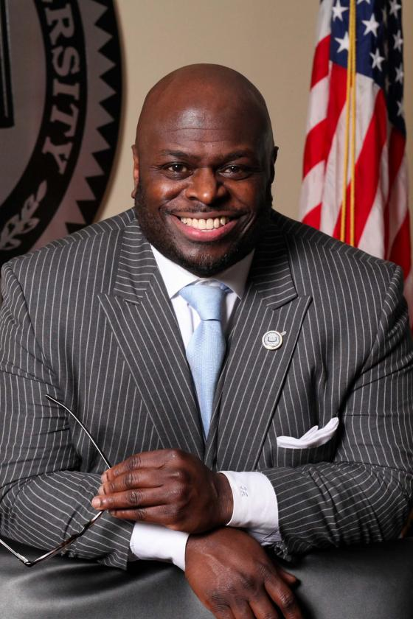

Relaunching Discover Rotary March 17th
Plan to invite prospective members to learn about our fantastic Club. This program takes place every 3rd THURSDAY at 11:15am preceding our weekly meeting and provides an excellent tutorial to whet their appetites before enjoying luncheon and our dynamic speaker. What better way to grow membership than to let them experience it for themselves!

Reconnect with FUN & Fellowship – 1st WEDNESDAY of each month
Coffee with the Executive - Greenville BrewHaHa on March 2nd 8am-9:30 am
Riverfront walk & happy hour at Bank’s Seafood on April 6th 5pm-7pm

**Be on the lookout for Outlook Calendar invites and an Eventbrite link for the April event***

Community Service in ACTION
RCW has partnered with the DE Association for the Education of Young Children to obtain a $4000 District Rotary Grant (which deaeyc is matching for a total of $8000) to give scholarships to teachers of young children in our partner agencies, including 10 hours of free professional development programs. What a boon to our ongoing efforts to make a difference in childhood education in our State!

Our collaboration with the DE Readiness Team and the Dolly Parton Imagination Library to fund and create literacy kits for our community partners was a great success! In particular, the teachers at KIngswood Community Center Early Learning Academy have been putting those Dolly Parton provided books to use the minute they arrive and working with parents on how best to use the literacy kits when they read to their children at home. Studies show time and again that children who are read to regularly at home are more successful at school in readiness, literacy, and comprehension….it takes a village and RCW is helping to lead the way!

Ashley

Ashley B. Cloud
Club Executive
Rotary Club of Wilmington
Community Service Building
100 W 10th Street Suite 1006 Wilmington, DE 19801
PO Box 685, Wilmington, DE 19899
Phone: 302.655.6025 | office@rotarywilmington.org


