
The Rotary Club of Wilmington, Delaware
Celebrating over 100 Years of Fellowship and Service
ISSUE 25 2016-2017 JANUARY 26 – FEBRUARY 2
UPCOMING PROGRAMS
January 26
Charles Allmond, Sculptor
Direct Carving in Stone & Wood
The award-winning sculptor will explain how he left
his successful law practice to pursue his passion – creating art
Program Chair: Lise Monty
Menu: Pork Cutlets with Brown Gravy, Mashed Potatoes and Vegetable
February 2 – Wilmington Mayor Mike Purzyicki
Program Chair: Carrie Gray
Menu: General Tso Chicken over Rice

February 9 – NO MEETING – EVENING SOCIAL
“LOVE and LAUGHTER on our LAPTOP”
Delaware Art Museum, 5:00-8:00
Beer, Wine, Scrumptious Appetizer $35/person
Send your silly, loving, serious photos, quotations, personalities, favorite cartoons to dhfdirector@dhf.org on or before midnight, February 7, 2017

February 16 – Stuart Comstock-Gay, President & CEO, Delaware Community Foundation
Program Chair: Dave Fleming
Menu: Seafood Stuffed Flounder with Old Bay Cream Sauce

BEER TASTING HAPPY HOUR JANUARY 18, 2017 IRON HILL BREWERY, RIVERFRONT

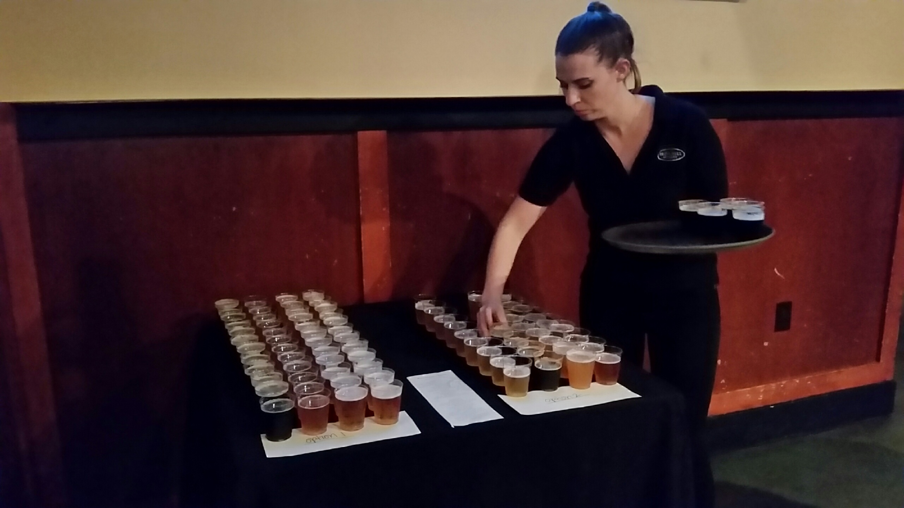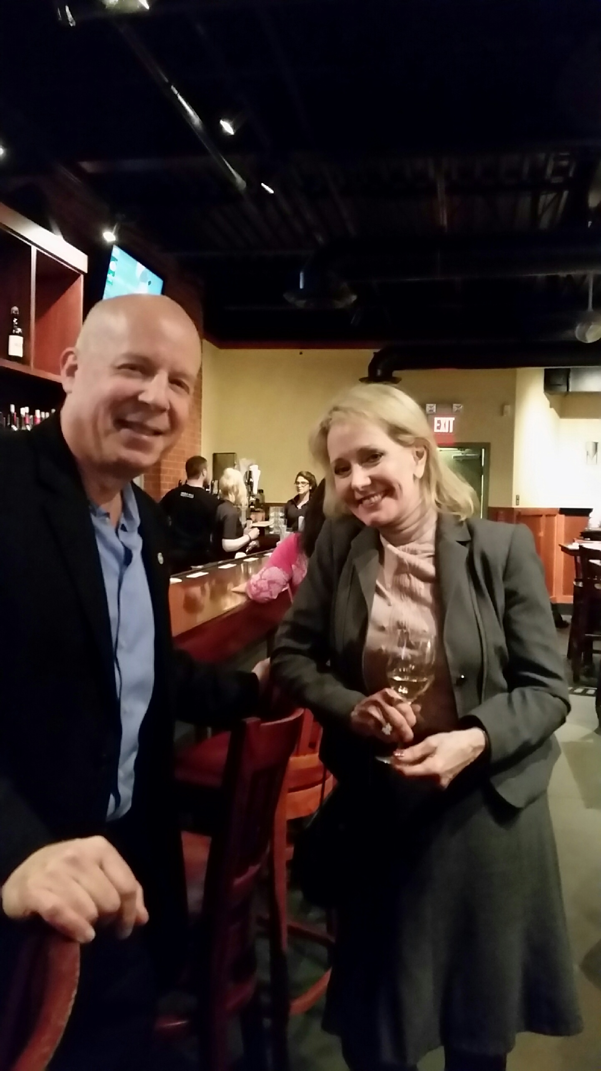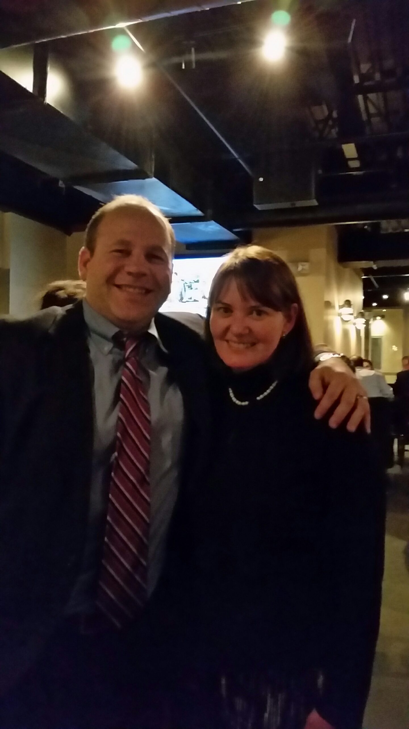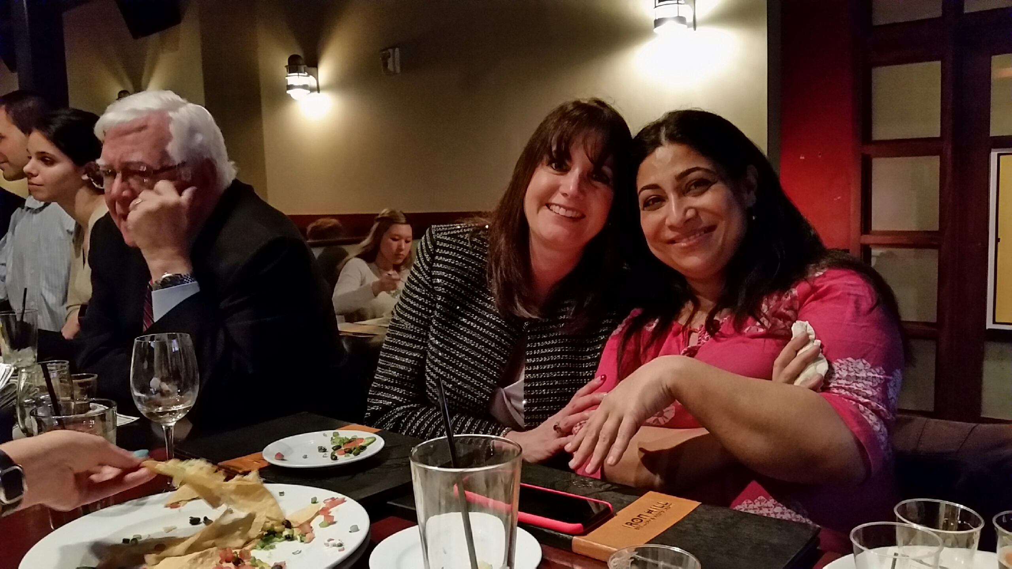
Plenty of special beer to taste Eric & Pat Keith & Amy Rotary Friendship – Cindy & Sheerin
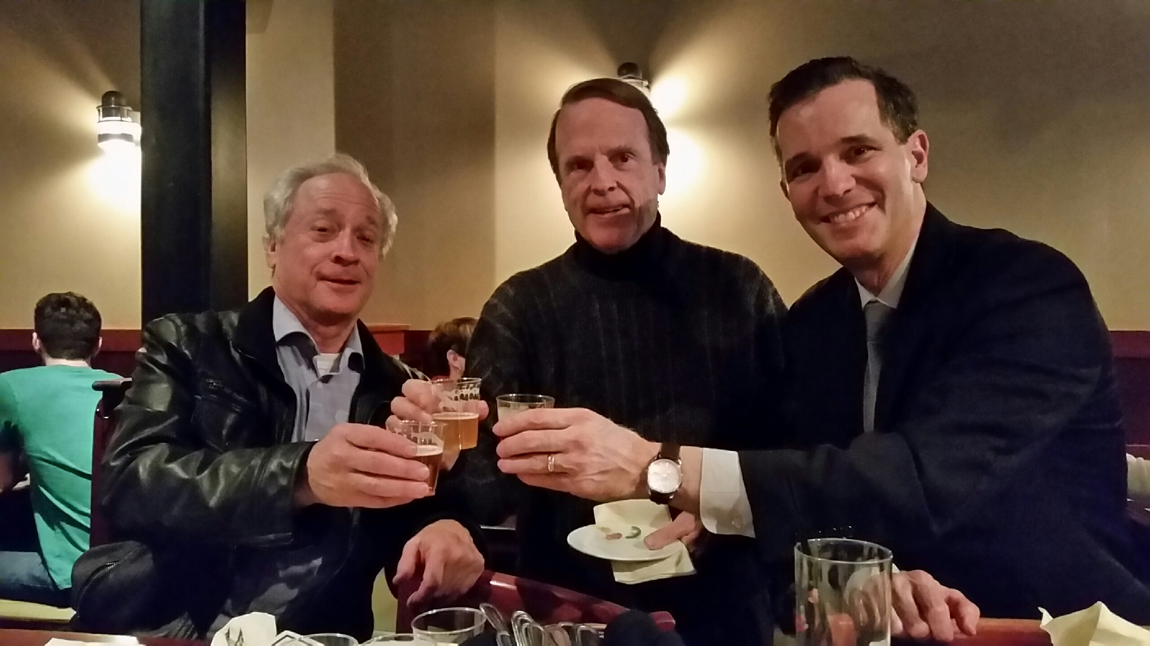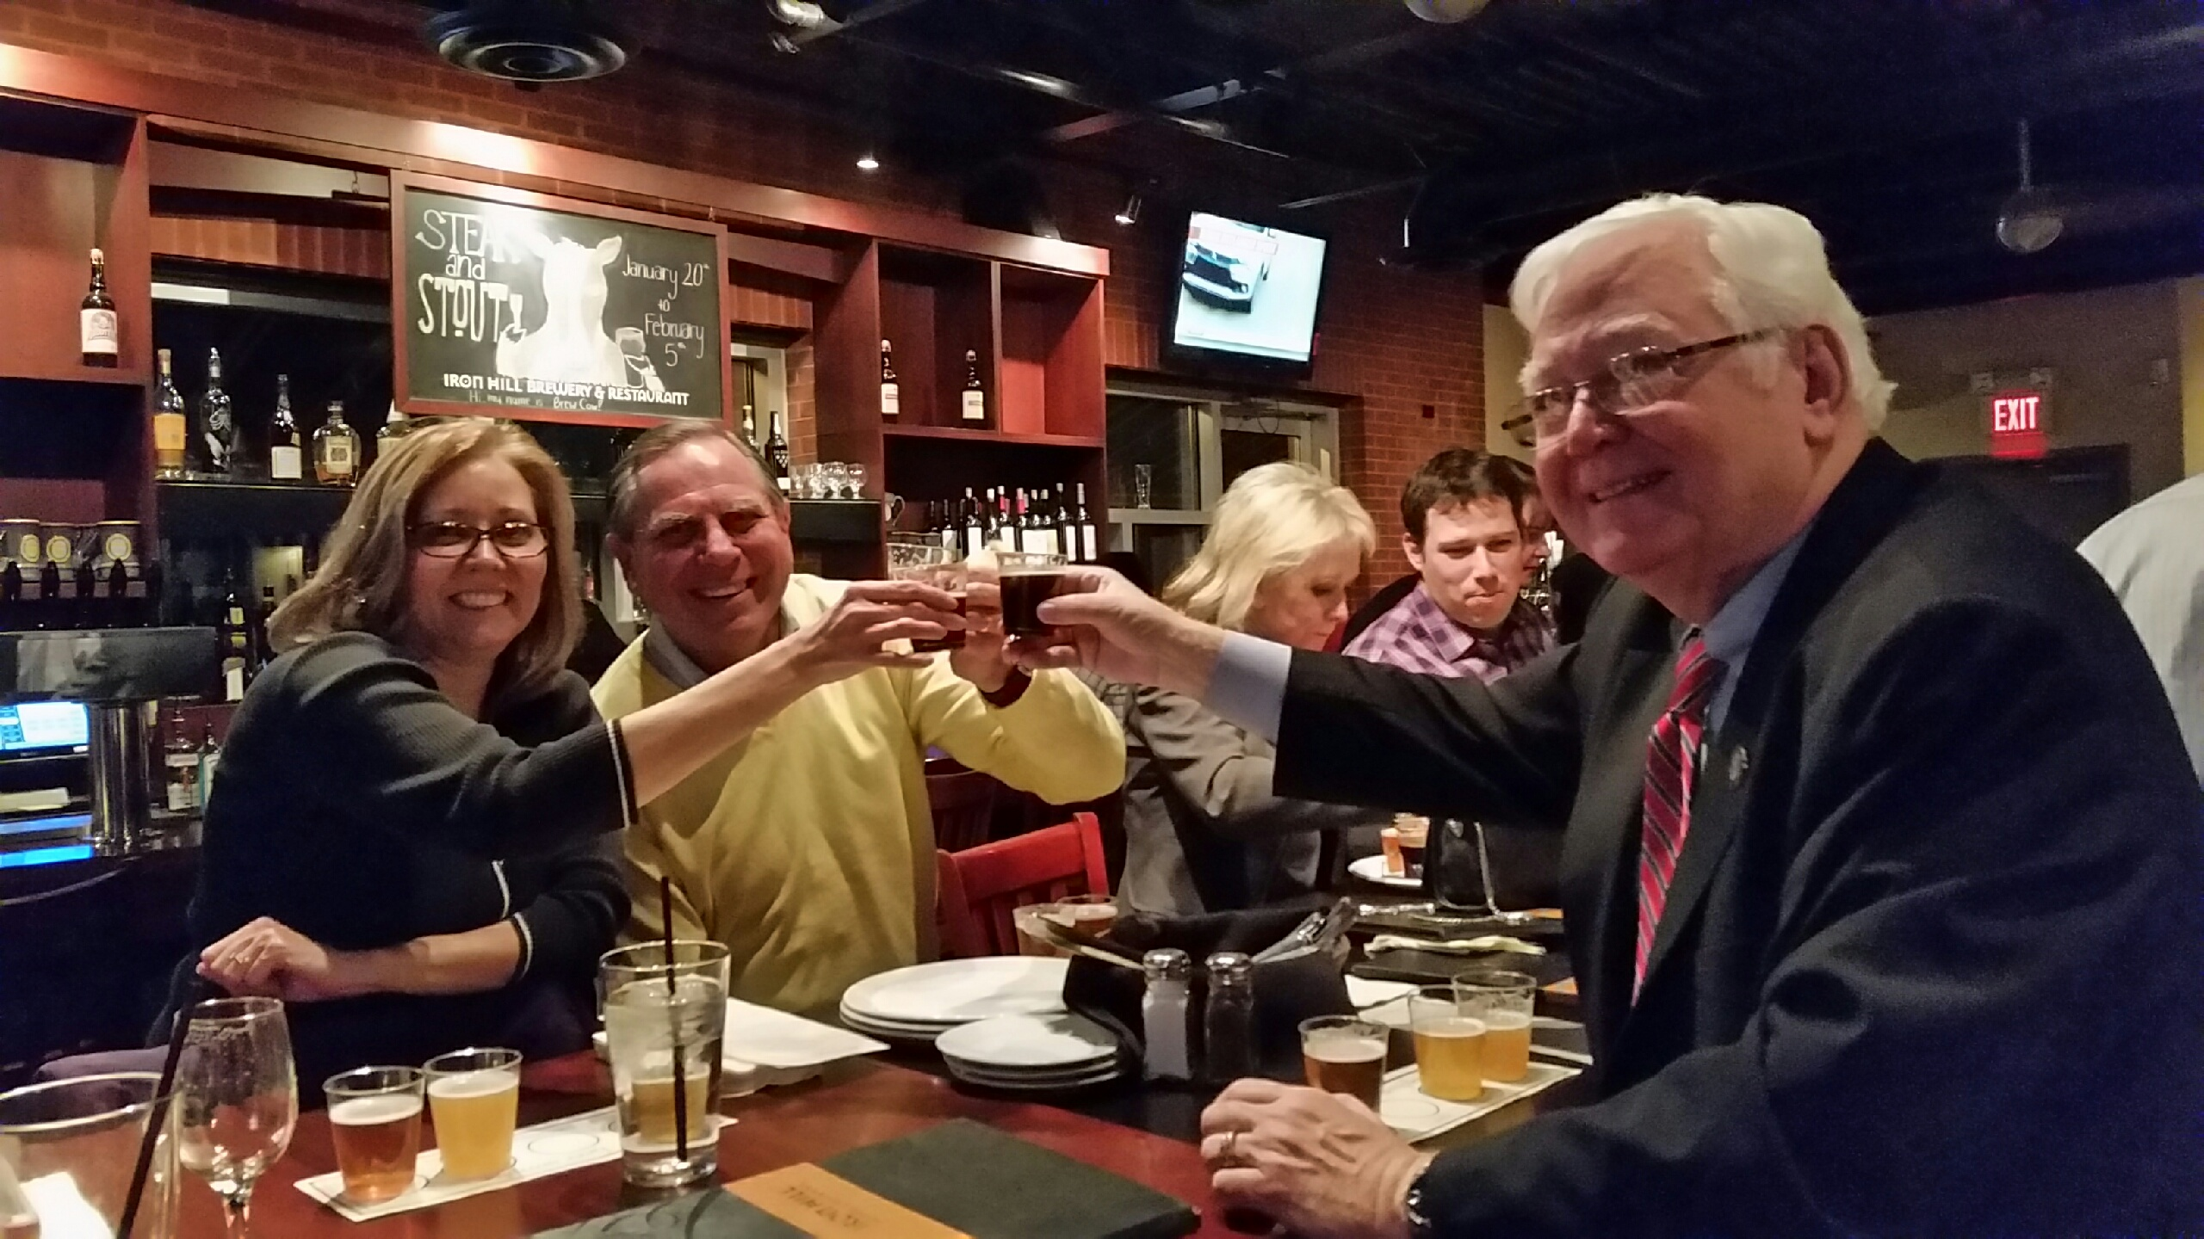
Mike, Kai, John Campanella toasting the evening Lisa, Matt, Sam – good friends; good beer
Minutes for Meeting of January 19, 2017
President Kai Lassen called the meeting to order at 12:10pm at the Hotel du Pont. The Club joined together in singing “America The Beautiful” led by Patty Downing with Elizabeth Rhoads on the piano. Michael Arrington provided the invocation.
Announcements: President Kai welcomed one guest. President Kai then called on Anne Eidschun, Chair of the Nominating Committee who announced a special election to augment the officers and directors election held in December to fill one remaining Board seat. The Nominating Committee nominated Keith Kepplinger as a Director for the 2017-19 Rotary years. Nominations were closed and a motion was made and seconded to make Keith a Director. The vote of the club was unanimous in approval. Marilyn Whittington announced a special “Love & Laughter” outing scheduled for Thursday February 9 (in lieu of the regular luncheon meeting) from 5PM until 8PM at the Delaware Art Museum. The event will feature writings, favorite pictures, something funny or endearing and personal from each member, wine and beer – all at a cost of only $35 per person. President Kai thanked Joan Sharp and Ajit George for putting on a great program at the Baby Grand last Sunday with the Martin Luther King Competition.
Program: Program Chair Sue Knisely introduced our speaker James Thompson and others at the Head Table including, in addition to President Kai and acting Secretary Dave Fleming included Teresa Avery, Rosi Crosby, Dori Jacobson, and Andrew Johnson.
Mr. Thompson, who grew up in Wilmington, has written extensively on the impact changing technology had on the art of America’s greatest illustrators during the Gilded Age. He defined for us a cycle of continuous innovation in transferring illustration to the printed page during the period of 1880 through 1917. At the beginning of that time, illustrators like Howard Pyle would use the most basic etchings to illustrate their writings. Etchings, difficult and time consuming to transfer to the printed page, were replaced by Lithography that used a gum Arabic solution to create a continuous tone image of light and shadow. Chromolithography introduced color inks to the process one at a time. Photolithography created half tone images from photo negatives by shining light through negatives onto treated paper. Color photolithography finally led to color photography. Artists like Pyle continuously evolved their artistic techniques to take advantage of these increasingly crisp and exciting imaging technologies. N.C. Wyeth’s Treasure Island in 1913 and Robin Hood in 1917 fully demonstrated the exciting new world of color illustrations. As America entered WWI, it had to quickly raise a standing army. The dramatic color posters and ads that proliferated have been credited with allowing an army of 200,000 to grow to 2 million by 2018. The meeting ended at 1:30 pm. Respectfully submitted, Dave Fleming, Acting Secretary

THANKS TO ALL OF OUR SALVATION ARMY BELL RINGERS THIS YEAR
Total Hours: 24
Total Red Kettle Collections: $1294.17
Our efforts this past holiday season helped the Salvation Army provide nearly 5000 local residents with assistance with Christmas. In addition, these funds allowed the SA to continue to provide the necessary year-round programs to assist others and keep our community thriving. It is your willingness Rotary members to give and your dedication to follow through that helps them to continue “Doing the Most Good.”

WE ARE GETTING CLOSER TO OUR NEW WEBSITE
We are building a new website that will be full of
great new content and easier to use
Please be patient with us until the new site is up and fully functional.
There will be no charge payments taken at this time or
scanners for attendance – you will need to sign in.
We are getting closer to completion . . .
COMMITTEE MEETINGS / DATES / EVENTS
February 9 Special Evening Activity – NO MEETING
Love and Laughter on our Laptop 5:00-8:00pm
Delaware Art Museum
February 22 Board Meeting, 8:00 am, Howard High School
February 17-19 RYLA Presentation, Carousel Hotel,
1:30 pm, Ocean City, MD
April 21-22 Camp Fairlee Clean Up
May 19 Camp Fairlee Campaign Celebration

