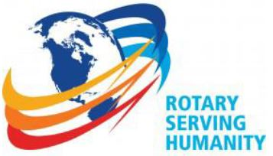
The Rotary Club of Wilmington, Delaware
Celebrating over 100 Years of Fellowship and Service
ISSUE 20 2016-2017 DECEMBER 3 – DECEMBER 15
UPCOMING PROGRAMS

December 1
Arreon A. Harley
Director of Music and Operations
The Cathedral Choir School of Delaware with Performance
Program Chair: Norm Veasey
Menu: Filet of Flounder with Lemon Vin Blanc, Rice and Vegetable

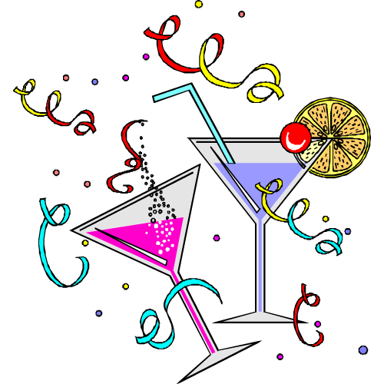
Annual Holiday Party
Thursday, December 8th (No Meeting) 6-9 PM
Delaware Center for the Contemporary Arts
200 S. Madison Street, Riverfront
Rotary Bar, hors d’oeuvres & Food Stations
$65 per person, $24 lunch credit for members
Transportation available from our Transportation Committee members
Sign Up in Lobby or with Sue

December 15 – Deborah Brooks, Co-Founder & Executive Vice Chairman
Michael J. Fox Foundation for Parkinson’s Research
Program Chair: Bill Jeremiah
Menu: Dijon Roasted Pork Loin, Roasted Red-Skin Potatoes, Vegetable
~~~~~~~~~~~~~~~~~~~~~~~~~~~~~~~~~~~~~~~~~~
MANY THANKS TO THE McDONALD FOUNDATION FOR THEIR
$15,000.00 GIFT TO OUR CLUB’S STUBBS SCHOOL PROJECT THIS YEAR
The Ellice and Rosa McDonald Foundation was established many years ago by Wilmington Delaware area philanthropists. The goal of the Foundation is to provide assistance to worthy causes Mr. and Mrs. McDonald devoted their lives to assisting. They left the bulk of their estate to their foundation upon their death. Accordingly, the charitable, educational and service organization which they believed in and the good works they devoted their lives to accomplishing are continued to this day by the three trustees of the Foundation, one of whom is Murray Sawyer who was privileged to serve as the personal attorney for Mr. and Mrs. McDonald for more than a quarter century.

Minutes for Meeting of November 17, 2016
President Kai Lassen called the meeting to order at 12:10 pm at the Hotel du Pont’s Gold Ballroom. The Club joined together in singing “My Country Tis of Thee” led by Bob Reed and guest pianist David Brown. The invocation was offered by Patty Downing. During our lunch prior to the program start our guest Pianist David Brown played “God Save the Queen.”
Announcements: President Kai made the following announcements. Today’s meeting we are celebrating Rotary Foundations Centennial by singing the Happy Birthday song and having Birthday cake as our dessert. Clif Hutton Rotary District Governor and Tom Shea made the presentations of our Paul Harris fellows. Paul Bechly is a Paul Harris Fellow plus 6. He also recognized two new Paul Harris Society Members; Caroline Chahalis and Kathryn Jakabcin. These two newest members were seated at a reserved table with our Club’s Paul Harris Society Members. President Kai had three calls to action; 6 volunteers needed this afternoon at the Bancroft School to help set out Thanksgiving dinner at 4:30, with dinner being served at 5:30 and clean up at 7:00; 5-8 volunteers needed on November 21 at Stubbs School from 11:30 until 2:00 to set up an assembly line to assemble Thanksgiving boxes and pack dry goods; 5-7 volunteers needed November 22 from 11 until 2 to load turkeys into the pre-packaged box of dry goods, add a pumpkin pie and distribute to the families. President Kai recognized Murray Sawyer for assisting us in getting a $15000 grant to our service foundation from the McDonald Foundation. He also announced a few reminders to sign up for the Salvation Army Bell Ringing which will begin December 5 through December 16. And our Holiday Party on December 8 from 6-9 at the Delaware Center for the Contemporary Arts. As a reminder, there will not be a meeting on December 8 due to the Holiday Party. President Kai urged all club members to get in their pledges. He also announced there will be no meeting next week on November 24, enjoy your Thanksgiving. On December 1 Arreon Harley and the Cathedral Choir School of Delaware will be performing for us.
Program: As an introduction to our speaker on the Rotary Foundation Michael Arrington wrote and performed a special song in celebration of Rotary Foundations 100-year Anniversary. The Program Chair was Elizabeth Rhoads who introduced our speaker Jeffry Cadorette and the head table.
Jeffry Cadorette has served Rotary in many different roles from District Governor to President’s Representative at numerous District conferences. In September of this year, Jeffry was nominated to serve on the Rotary International Board of Directors for 2018-2020. Among his many awards he has attained two of Rotary’s highest; Rotary International’s Service Above Self Award and The Rotary Foundation’s Distinguished Service Award.
Jeffry’s presentation today is “Rotary Foundation 100th Anniversary, 100 Years of Doing Good in the World.” His first order of business was to acknowledge the newest recipient of Level One major donor our very own President Kai. Both Elizabeth Rhoads and Clif Hutton presented President Kai his award. Jeffry’s presentation began with the acknowledgement of November being Rotary Foundation month. He made a parody on the pharmaceutical ads and developed an ad of his on for Rotary. In celebration of the Rotary Foundation’s 100th anniversary of service to humanity, he reviewed the six main objectives of the organization. Jeffry emphasized that consistent support makes you feel like you are doing your part. He made an appeal to our members to donate any amount. It doesn’t matter how much just donate. Every member should make a donation and our Club goal should be 100% participation. As Rotary Members we own and direct what the Foundation does. Charity navigator gives the Rotary Foundation consistent 4 star ratings for efficiency and effectiveness of every dollar donated. The Rotary Foundation also is the recipient from the Association of Fundraising Professionals award for Outstanding Foundation. If there was ever a time to dare to make a difference it is now. Don’t be overwhelmed by the enormity of need just help someone somewhere. I can, I will and I must because there is a child waiting for your help.
Jeffry showed a 3 minute video of the faces of people we are helping around the world. He closed by sharing a poem titled “The Cold Within.” Your contributions keeps the fire burning hot and bright for the Rotary Foundation. He appealed again for every Rotary member to make a donation in this centennial year to keep the fire burning.
President Kai closed the meeting by giving Jeffry a book of our club’s history celebrating our centennial in thanks of his speaking today. The meeting ended at 1:30 pm. No committee meetings following the meeting. The meeting ended at 1:30 pm. Respectfully submitted, Lisa Detwiler, Acting Secretary
SALVATION ARMY BELL RINGING

MONDAY, DECEMBER 5 THROUGH FRIDAY, DECEMBER 16
SIGN UP AT MEETING OR WITH SUE – WE NEED BELL RINGERS ! ! ! ! !
COMMITTEE MEETINGS / DATES / EVENTS
December 01 Youth Services
December 05-16 Salvation Army Bell Ringing, 9th & Market
December 08 Annual Holiday Party, DCCA, Riverfront
December 14 Board of Directors Meeting
December 15 History (Last Meeting for the year)
December 22 NO MEETING – HAPPY HOLIDAYS
December 29 NO MEETING – HAPPY NEW YEAR 2017

