Ashley Cloud
From: Ashley Cloud
Sent: Mon, 7 Feb 2022 16:36:26 +0000
Bcc: Allison T. Levine (alevine@delcf.org); Amy Bielicki (Amy.Bielicki@ChristianaCare.org); Andrew Johnson(AJohnson@coverrossiter.com); Anne Eidschun (Anne.Eidschun@griswoldhomecare.com); Atul Chugh; Audrey Boys (Audrey.Boys@me.com); Basile Njei(basilenjei@gmail.com); Bill Holloway (holloway@bernardon.com); Bill Jensen; Bill Medford (wmed4@aol.com); BillyLane(cgmalliswell@verizon.net); Bob Reed; BrandonBrice(bbrice@uwde.org); Brenda Romeus(BrendaR@kwcommercial.com); Bruce Swayze (bswayze@wscins.com); Buck Smith (HCSVette@aol.com); Cam Yorkston (yorkstonconsulting@comcast.net); Caroline Jones (carolinejones@kindtokids.org); CarrieGray(carriewgray@hotmail.com); Catrina Jefferson (catrina.jefferson@cscglobal.com); Charles Elson(charlesm_elson@comcast.net); Charley Broll (cbroll@aol.com); Charlie McDowell (cmcdowell@potteranderson.com); Chris Daney; Christian.Ian.Bale@gmail.com; Cindy Campanella(CCampanella@bancroftusa.com); Cynthia Morgan (cynthiaperspective@gmail.com); Dave Fleming(flemingdw67@gmail.com); DaveSchaen(DavidLSchaen@icloud.com); David DeVoll (david.devoll@yahoo.com); David Rhoads (dgrhoads@dgrhoads.us); David Woods (David.Woods@delautism.org); David Young(dyoung@dehistory.org); Deborah Bagatta-Bowles (dbowles@ymcade.org); Donald Parsons (dfparsons2@gmail.com); Dori Jacobson (dorijacobson@mac.com); Elizabeth A. L. Rhoads (erhoads@dgrhoads.us); Norm Veasey (eveasey@gfmlaw.com); Robert Katzenstein; Robert Reardon (rreardon66@gmail.com); FrederickEbede(admediade@yahoo.com); Gene Julian (eugene.julian@comcast.net); George Alderman (galderman32@comcast.net); Gil and Alice Smith (agsjr@verizon.net); Gina Kennedy(gkennedy@che-east.org); Giovanni P. Conigliaro (giovanni@nsolutionist.com); GregBallance (gballance@diamondtechnologies.com); Guillermina Gonzalez (contactguille@comcast.net); HeatherMorrissey(HMorrissey@delart.org0; Ian R. McConnel (Ian.McConnel@cscglobal.com); Jaime Wills; JakabcinKathryn (KJakabcin@ycst.com); Jane C. W. Vincent (jcvincent@gmail.com); Jean G. Dahlgren (president@dcad.edu); Jim Ellison (james.m.ellison@christianacare.org); Jim Lee(jlee@stratfi.com); Joan DelFattore (jdel@udel.edu); Joan Hoge-North(jhoge-north@delcf.org); Joan Sharp; Joe Melloy (jmelloy@msn.com); John B. Morton Jr. (jbm42@msn.com); John Jornlin (jjornlin@wilmingtontrust.com); John Matarese (JMatarese@wsfsbank.com); John Newlin(middlemadness@gmail.com); John Potter (john.d.potter@verizon.net); John S. Cigler (jcigler@cbhinc.org); Jonathan Diamond (jonathandiamond33@hotmail.com); Jonathan Hickey (jonhickey@emoryhill.com); Joseph E. Carbonell (joecarbonell3@gmail.com); Joseph Setting (joe@setting.com); Julia Bettin Klein(klein@kleinllc.com); KaiLassen(Kailassen@gmail.com); Karen Kegelman(kkegelman@choirschoolofdelaware.org); Kate Cowperthwait (cowperthwaitkate@gmail.com); Ken Grant(kgrant@aaamidatlantic.com); Ken Sklenar (ksklenar@esdel.org); Kevin Smith (klsmith@habitatncc.org); Larry Gehrke (lgehrke845@aol.com); Larry Zutz (lawrence.zutz@usi.biz); Lisa Detwiler:ldetwiler@ssdel.com; LisaMore (lisamore96@icloud.com); Lossie Freeman (lossiefreeman@googlemail.com); Lynn Jones (lynncjones77@gmail.com); Madeleine Bayard (mbayard@rodelfoundationde.org); MargiPrueitt(m.h.prueitt@gmail.com); Marsha Borin (mborin@comcast.net); Martha Gilman (marthag@gildevco.com); Mary Jo Anderson (andersmj44@gmail.com); MATT BEARDWOOD; Matt Brown; Matt Urban (murban@nupointmarketing.com); Michele Anstine(MAnstine@dehumanities.org); Mike Staman(Michael.Staman@schwab.com); Murray Sawyer (hms@WestoverCapital.com); Peg Laird (peglaird@me.com); David Harrison(dharrisononleave@gmail.com); MaryChan(nahcyram@gmail.com); NancyBlumberg(nbjb4@comcast.net); Neta Pringle (npringle@msn.com); Nicki Pickles (npickles@cscde.org); Noel Burnham (nburnham1234@gmail.com); Pam Cornforth (Pam Cornforth); Patrice Gilliam Johnson (pgjohnson@desu.edu); patricia@trinityparishde.org; Paul L. Bechly (paul.bechly@morganstanley.com); PeggyAbleman(placourtlyme@yahoo.com); Pete Booker (peteb81151@gmail.com); PeterHorty@aol.com; PhilipForkpa(philipforkpa2007@yahool); Ralph D. Marshall (rmarshall@wilmingtonfinancial.com); Ranney Ward (PW19807@comcast.net); Rich Williams (rlwilliams@ashland.com); Richard Flanagan (rdf3131@verizon.net); Richard J. Gessner (rjgessner@hotmail.com); Richard Paverd - ICT LLC (rpaverd@inttec.com); Richard Stat [RStat@statorganization.com]; Robert Martinelli (rmartinelli@todaymediainc.com); Robert McCoy(rcmccoy@me.com); Rosalyn Keesee(rosalynk@dciarchitects.com); RyanRose(ryan.rose@foxroach.com); santiagorojascarbonell@gmail.com; Sam Waltz (SamWaltz@SamWaltz.com); Samantha Diedrick; SamuelMoultrie(moultries@gtlaw.com); Sheila Bravo (sbravo@delawarenonprofit.org); Stanley Diver (smd@diverandassociates.com); Steve Novack (Steve.novack@comcast.net); Sue Knisely; Ted Geist (Eggeist1@gmail.com); Thorpe Moeckel; Tim Lyons (tlyons@lyonsinsurance.com); Tom Henderer (thenderer@comcast.net); Tom Shea (tshea@marycampbellcenter.org); Tom Smith(tdsmith@visitingangels.com); Tucker Robbins(tucker@robbinsrealestate.com); VinceEpiscopo(vepiscopo@ncall.org); Warren Du Pree(warrendupree@yahoo.com); Wil Sherk; Will Minster (wjminster@gmail.com); Yair D. Robinson (rabbirobinson@bethemethde.org)
Subject: Rotary News & Notes - 2.10.22 speaker John Riley "Porky Oliver" via Zoom
Attachments: RCWdirectory2021-2022.pdf
Good Morning Rotarians,

Our Club is a beautiful balance of history and progress. Take our Club Directory for example: I discovered some beautiful gems hailing from 1944-1947 in our archives and could not wait to share them with you. As I stroll through the past, your desire for an updated Directory awaits me in the present!

Never fear: I am sharing an attachment in this email of the 2021-2022 “Interim Directory” as a PDF document that you can print or save at home. PLEASE review your information so I can make any necessary updates. A more formal Directory is in the works. I love that our Club has such deep roots and rich history, but is ever ready to serve in the present and move forward into the future as a vibrant, active group.

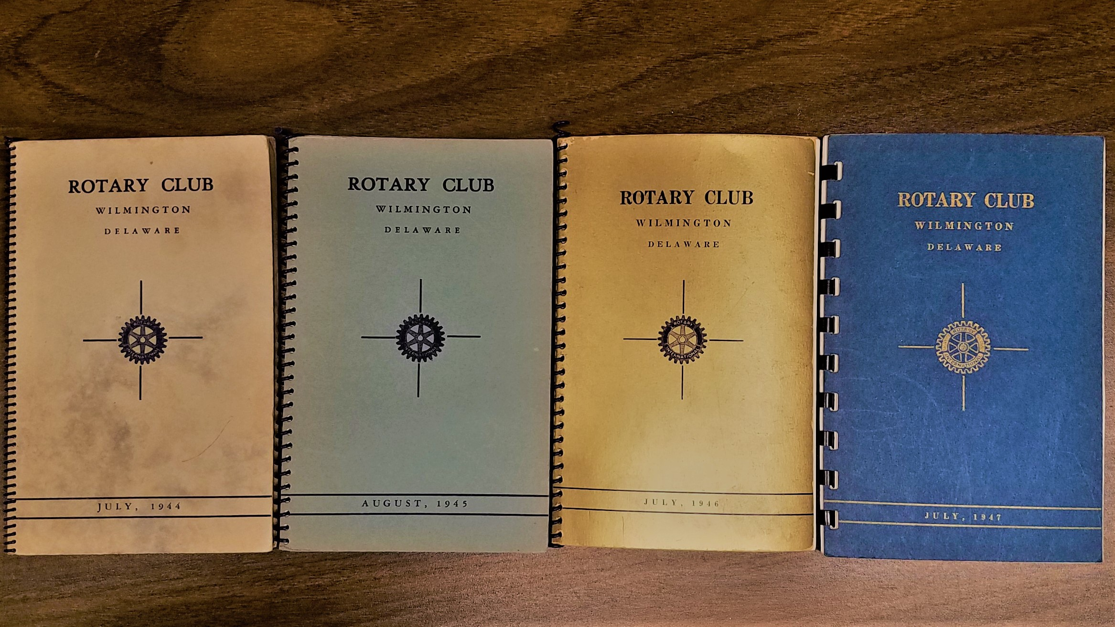

John Riley – author of “How He Played the Game: Ed Porky Oliver and Golf’s Greatest Generation”

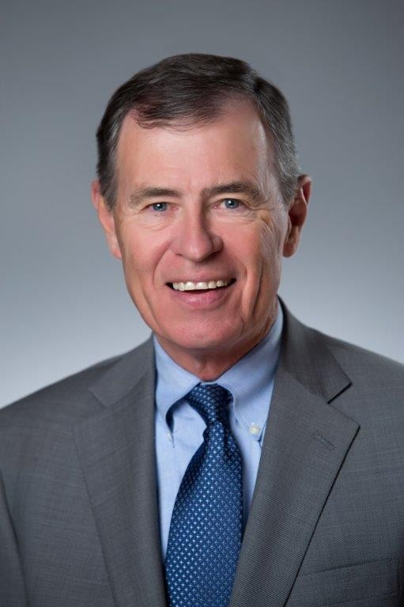

Zoom link: https://us02web.zoom.us/j/7972453263

Meeting ID/Passcode: 797 245 3263

Manual Dial-in: (646) 558-8656

RCW visiting other Clubs!

Community Service Committee members (Lynn Jones, Madeleine Bayard, Pete Booker) have been proactively sharing our work on Early Childhood Education advocacy with other Delaware Rotary Clubs to encourage Rotarian collaboration on this important topic:

Camden/Wyoming
Dover Capital
Lewes
Newark
Rehoboth
Smyrna

Check out Lynn Jones in action!

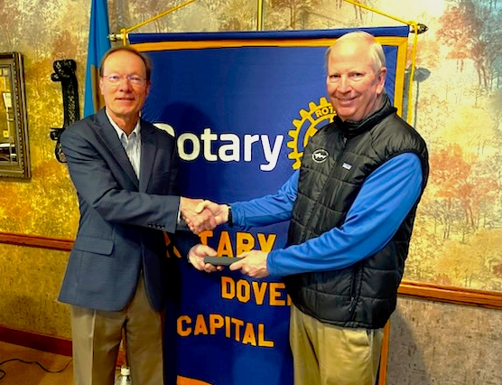

Taking advocacy to Legislators:

Rotarians Don Parsons, Margi Prueitt, and Lynn Jones have met with key members of the Legislature and the Joint Finance Committee to make the case for the importance of ensuring Early Childhood Education is easily accessible to all families in Delaware for the sake of a brighter, more successful future for youth in our State. Key supporters such as Dave Sokola and Stephanie Boulden presented at our 12/2 meeting and shared their views on the subject.

How can you get more involved? Use your voice to let our leaders know how important it is that enough of the Governor’s proposed 2023 budget be allocated to support sustainable child care and education initiatives for the future of Delaware’s children:

bit.ly/child-care-fy23-budget

Mark your calendars for FELLOWSHIP
Wednesday March 3rd 8am-9:30am Coffee with your Executive Ashley B. Cloud at the Greenville BrewHaHa

Upcoming Speakers
March 3rd – Dave Gula WILMAPCO & Rep. Sherry Dorsey Walker “Bridging I95, Reconnecting the Community”
March 10th – “Our Path Forward” Club planning meeting
March 17th – JoAnn Balingit, former Poet Laureate “Poetry and the Possibility of Building Communities”

Thank you!

Ashley
Ashley B. Cloud
Rotary Executive

Rotary Club of Wilmington
Community Service Building
100 W 10th Street Suite 1006 Wilmington, DE 19801
PO Box 685 Wilmington, DE 19899
Phone: 302.655.6025 | office@rotarywilmington.org


