
The Rotary Club of Wilmington, Delaware
Celebrating over 100 Years of Fellowship and Service
ISSUE 6 2016-2017 AUGUST 18 – AUGUST 25
UPCOMING PROGRAMS
August 18
Julane W. Miller-Armbrister
Peggy Geisler, Project Director
“The Delaware Center for Health Innovation and
the DCHI Healthy Neighborhoods Program”
An overview of DCHI and the State Health Care Innovation Plan, which will include a focus on the Healthy Neighborhood’s program. The Healthy Neighborhoods program is a strategic initiative to drive progress toward improving population health and addressing health-related social issues.
Program Chair: Roy Roper
Menu: Vegetable Lasagna with Beshamel Sauce

August 25 – Adriana LaCorte & Pina De Rosa, Freelance Documentary Producers
“Sniffing out Cancer: The Making of a Groundbreaking Documentary
about Early Cancer Detection”
Program Chair: Ajit George
Menu: Grilled Flank Steak, Roasted Red-Skin Potatoes, Vegetable

September 1 – Tim McDermott, Chief Business Officer, Philadelphia Union
Program Chair: Matt Stehl
Menu: Cracker-Crusted Haddock with Wild Rice

SHARING TIME WITH ROTARY INTERNATIONAL PRESIDENT JOHN GERM
Monday, August 15, 2016 and Tuesday, August 16, 2016
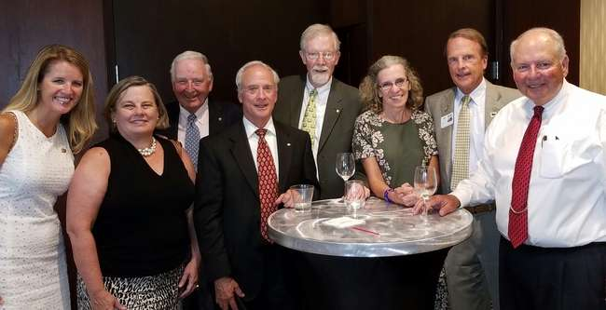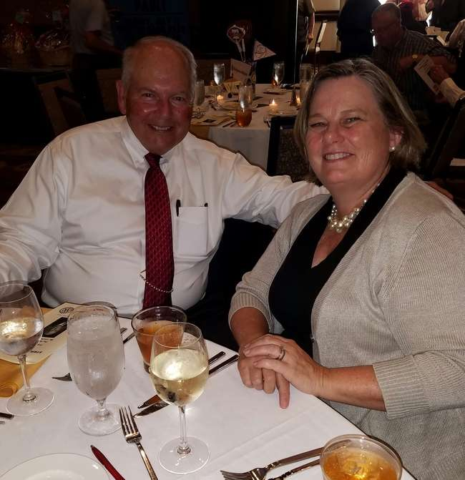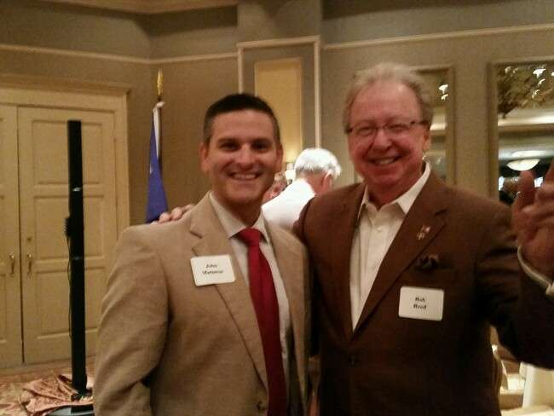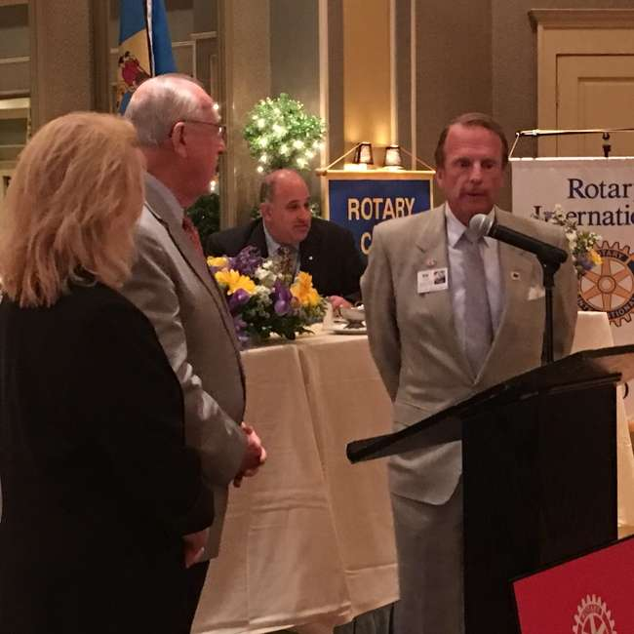
DINNER IN MT. LAUREL NJ, LUNCH BRANDYWINE-NAAMANS MEETING, PHILLIES BASEBALL GAME
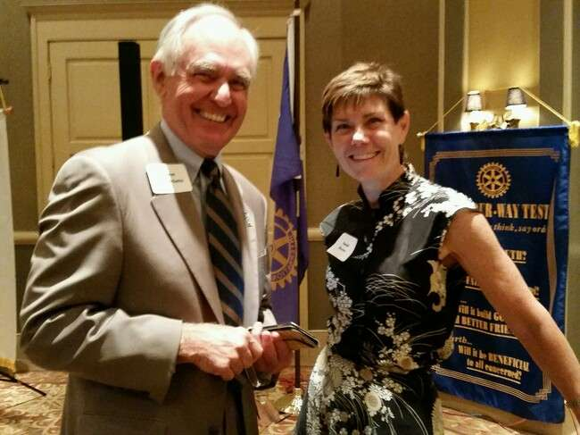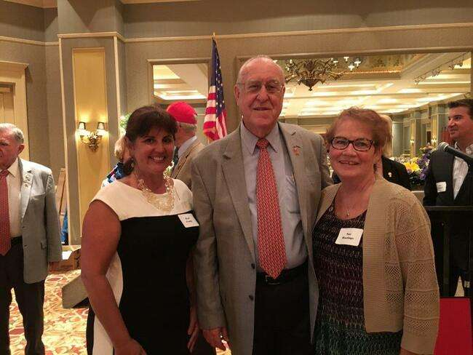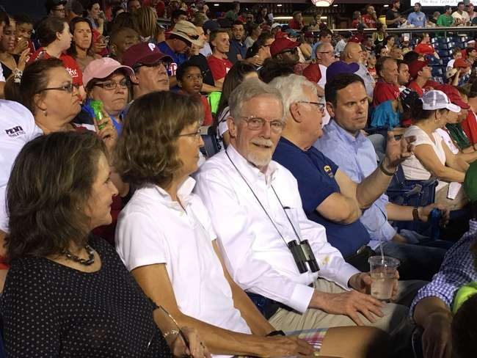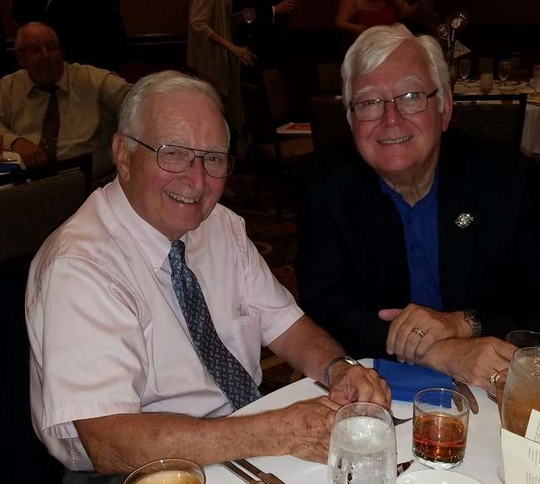

Minutes for Meeting of August 11, 2016
President Kai Lassen called the meeting to order at 12:10pm at the Hotel du Pont. The Club joined together in singing “America, the Beautiful” led by Michael Arrington with Kathryn Jakabcin on the piano. Cynthia Morgan provided the invocation.
Announcements: President Kai welcomed several guests. President Kai then called on Lise Monty who provided an update on the Unity School in Pakistan and shared a thank you note written by the Rotary Pakistan Chair of the Project for the girls’ school expressing their gratitude for our assistance over the past five years. The last class just graduated and many of the young ladies have been accepted into colleges and universities. This is a remarkable achievement since they live in a deprived community. They are thankful that Rotary and the Unity School provided them with wonderful enrichment and educational opportunities. President Kai called Meredith McAloon to encourage members to attend Rotary Leadership Institute on Saturday, October 22 at Cecil College in Northeast, MD where Parts I, II and III will be offered. Please contact Sue if you are interested and she will register you for the class. Please note that the Club will pay for 10 people to attend this fantastic program. President Kai thanked the McDonald Foundation for their very generous gift to the Centennial Park last year, which has been earmarked specifically for the education stations. He also shared a message from RI President, John Germ, which is to invite people to join Rotary as we need many caring hearts and more bright minds to move our work forward.”
Program: As part of the introduction of our speaker, the Club joined together in singing a Wilmington Rotary modified version of “Kodachrome,” written by Paul Simon. “Chromosome,” written by our legendary ‘songwriter’ Michael Arrington, accompanied by Kathryn Jakabcin on the piano, had a lasting impression on our speaker and the attendees – thank you, Michael! Wil Sherk offered the traditional introduction of our speaker, Dr. Eric Kmiec.
Dr. Kmiec, Director of the Gene Editing Program at the Helen F. Graham Cancer Center and Research Institute, is well known for his pioneering work in the fields of molecular medicine and gene editing. He is also the founder of the Gene Editing Institute at Christiana Care, which provides genetic tools for gene editing and instruction in the design and implementation of these tools. The incredible work being done at the Helen F. Graham Center, under the direction of Dr. Petrelli, is progressive, and the Center is hoping to be named a Cancer Center of Excellence within the next three years.
The Gene Editing Institute has four focus areas: Translational Research and Technology Development; Development and Commercialize; INBRE Affiliated Genome Customization Care; and Educational Kits and Instructional Workshops. To learn more, please visit http://www.christianacare.org/geneeditinginstitute. Dr. Kmiec extended an invitation to visit the Gene Editing Institute as well.
Dr. Kmiec explained CRISPR, a revolutionary new technology tool in molecular biology. This genome editing tool allows scientists to create knock-in, knock-out, gene up regulation/repression, and mutations of genes in a laser sharp and targeted manner. Simply put, it is a gene editing toolkit utilized to repair defective genes (think spellcheck feature in Microsoft Word). Gene editing has met with much success in many fields, such as material sciences, food, and the medical field. This tool has reduced the gene editing process from approximately six months to 2 days. Gene editing testing conducted on pigs is yielding promising results for human organ replacement, which humans’ bodies have typically rejected. Current cases on monkeys have also experienced positive results related to the study of disease progression. This technology is even being utilized to prevent mushrooms from turning brown. The US Panel has approved the first gene editing human trial in the United States, which will be conducted by the University of Pennsylvania next year on t-cell leukemia. Great Britain had success last year on a child with t-cell leukemia, who now shows no signs of cancer. This was the first human case using CRISPR. Dr. Kmiec respectfully acknowledged ethical concerns associated with this technology.
Dr. Petrelli and Dr. Kmiec recently formed a highly specialized team at the Helen F. Graham Center to begin CRISPR work on lung cancer, which is a leading cause of death in Delaware. Their goal is to successfully treat lung cancer through gene editing. The meeting ended at 1:30 pm. Respectfully submitted, Cindy Campanella

SIGN UP IN LOBBY - MARK YOUR CALENDARS

Back Pack Stuffing
Tuesday, August 23 from 12-2 pm (at Stubbs Elementary)
Back Pack Give Away & Community Back-to-School Party
Thursday, August 25th from 4-6 pm (park behind Stubbs Elementary)
Please RSVP to Sue Hastings in the Rotary Office (office@rotarywilmington.org)
COMMITTEE MEETINGS / DATES / EVENT
August 18 Membership, Public Relations
August 23 Back Pack Stuffing 12-2 (Stubbs Elementary)
August 24 Board of Directors Meeting, Hotel du Pont, 8:00am
August 25 Back Pack Giveaway & Community
Back-to-School Party 4-6pm
RI President

