
The Rotary Club of Wilmington, Delaware
Celebrating over 100 Years of Fellowship and Service
ISSUE 24 2016-2017 JANUARY 19 – JANUARY 26
UPCOMING PROGRAMS
January 19 – James C. Thompson
Painting America’s Portrait
“How Illustrators Created America”
Illustrators were in their Golden Age when Woodrow Wilson declared war on Germany. Called to serve, they used their unique skills to help their Uncle Sam with that terrible war. Jim Thompson will explain what they did. This is the 100th anniversary of America’s entry into World War One.
Program Chair: Sue Knisely
Menu: Balsamic Grilled Flank Steak with Potato and Vegetable

January 26 – Charles Allmond, Sculptor, Direct Carving in Stone & Wood
The award-winning sculptor will explain how he left his successful law practice to pursue his passion – creating art.
Program Chair: Lise Monty
Menu: Pork Cutlets with Brown Gravy, Mashed Potatoes and Vegetable

February 2 – Wilmington Mayor-Elect Mike Purzycki
Program Chair: Carrie Gray
Menu: General Tso Chicken over Rice

February 9 – NO MEETING – SOCIAL EVENT – DETAILS TO FOLLOW
Activities Committee, Marilyn Whittington, Chair
Committee could use some volunteers!!! If interested, please contact Marilyn.

February 16 – Stuart Comstock-Gay, Delaware Community Foundation
Program Chair: Dave Fleming
Menu: Seafood Stuffed Flounder with Old Bay Cream Sauce

A Special Day with the Governor for our Howard Interact Students & Advisors
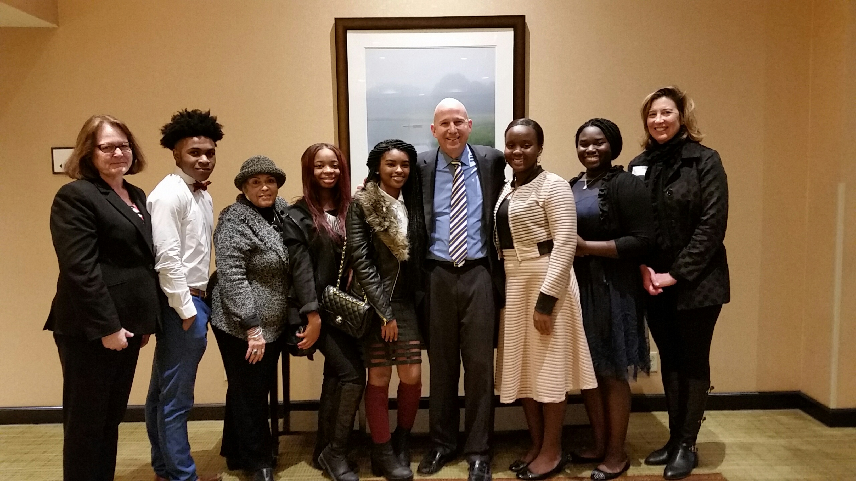
Joey Herman, Advisor, Chandler Abston, Deja Guy, Gwen Sanders, Rotary Advisor, Tyiana White,
Governor Markell,Destinee Lampkin, Ndella Jagne, Colleen Conaty

Minutes for Meeting of January 12, 2017
President Kai Lassen called the meeting to order at 12:10pm at the Hotel du Pont’s Gold Ballroom. The Club joined together in reciting the “Pledge of Allegiance” led by Elizabeth Rhoads. Michael Arrington provided the invocation.
Announcements: President Kai made the following announcements – Eric Braunstein – Beer Tasting, Wednesday, January 18, 5-7 pm, Iron Hill Brewery, Riverfront – this is a good time to bring a prospective member!; President Kai – please join him this Sunday, January 15, at 2:00pm when he represents our Club in presenting the award being given by our Club to the third place winner of the Dr. Martin Luther King Communication Contest for high school students; January is Membership month so please bring guests to upcoming meetings; and please pay your invoices as soon as possible.
Program: Sam Waltz provided an entertaining introduction of the head table and our speaker, Governor Jack Markell, Delaware’s 73rd Governor. Governor Markell’s presentation, titled ‘Delaware’s Economy, Where We’ve Been; Where We’re Headed’ was an outstanding overview of economic results from 2010- 2016. Governor Markell announced Delaware’s unemployment rate is 4.3%, we’ve surpassed the job growth goal, and we also passed the State’s previous jobs generated peak from years past. In fact, Delaware has outperformed all states in the region in job growth by 16%. Delaware and Indiana are the only two states in the country with a true increase in the job participation rate.
Governor Markell reported the following regarding Wage Growth in Delaware: 1) wage growth is 10.7% higher over the past year and is the fastest growing in the nation; 2) it has steadily increased the past few years; 3) during 2012-2014, Delaware’s median household income grew at the second fastest pace in the nation; and 4) over the past two years, the weekly wages of private sector workers in Delaware has grown by 17.8%, which is the fastest pace in the nation.
He also provided an update on the Path to Prosperity and Governor Markell shared that 27 students graduated from the program in the past year and now over 6,000 students participate in the program. This skills development program for Delaware students allows them to graduate with a nationally recognized and accredited certificate. He also stated that a high quality early education can dramatically move the needle in a positive direction for high school and college academic success. During his term in office, the State has opened 22 language emersion programs so students can be proficient in either Spanish or Chinese by the time they complete the fourth grade.
Governor Markell provided updates on the Downtown Development District and mentioned that $17.5 million of private money has been infused into the city to support positive initiatives for the community.
He reported that the number of employees in State Government has reduced by 500 people over the past eight years even though there has been a dramatic increase in the demand of services. The State Government is running very efficiently.
Lastly, Governor Markell thanked our club for the great work we do in the community and he encouraged us to continue to make a remarkable difference. The meeting ended at 1:30 pm. Respectfully submitted, Cindy Campanella, Secretary

Dr. Martin Luther King Jr. Communication Contest
Third Place Award Presentation (Club-Sponsored)
Sunday, January 15, 2017
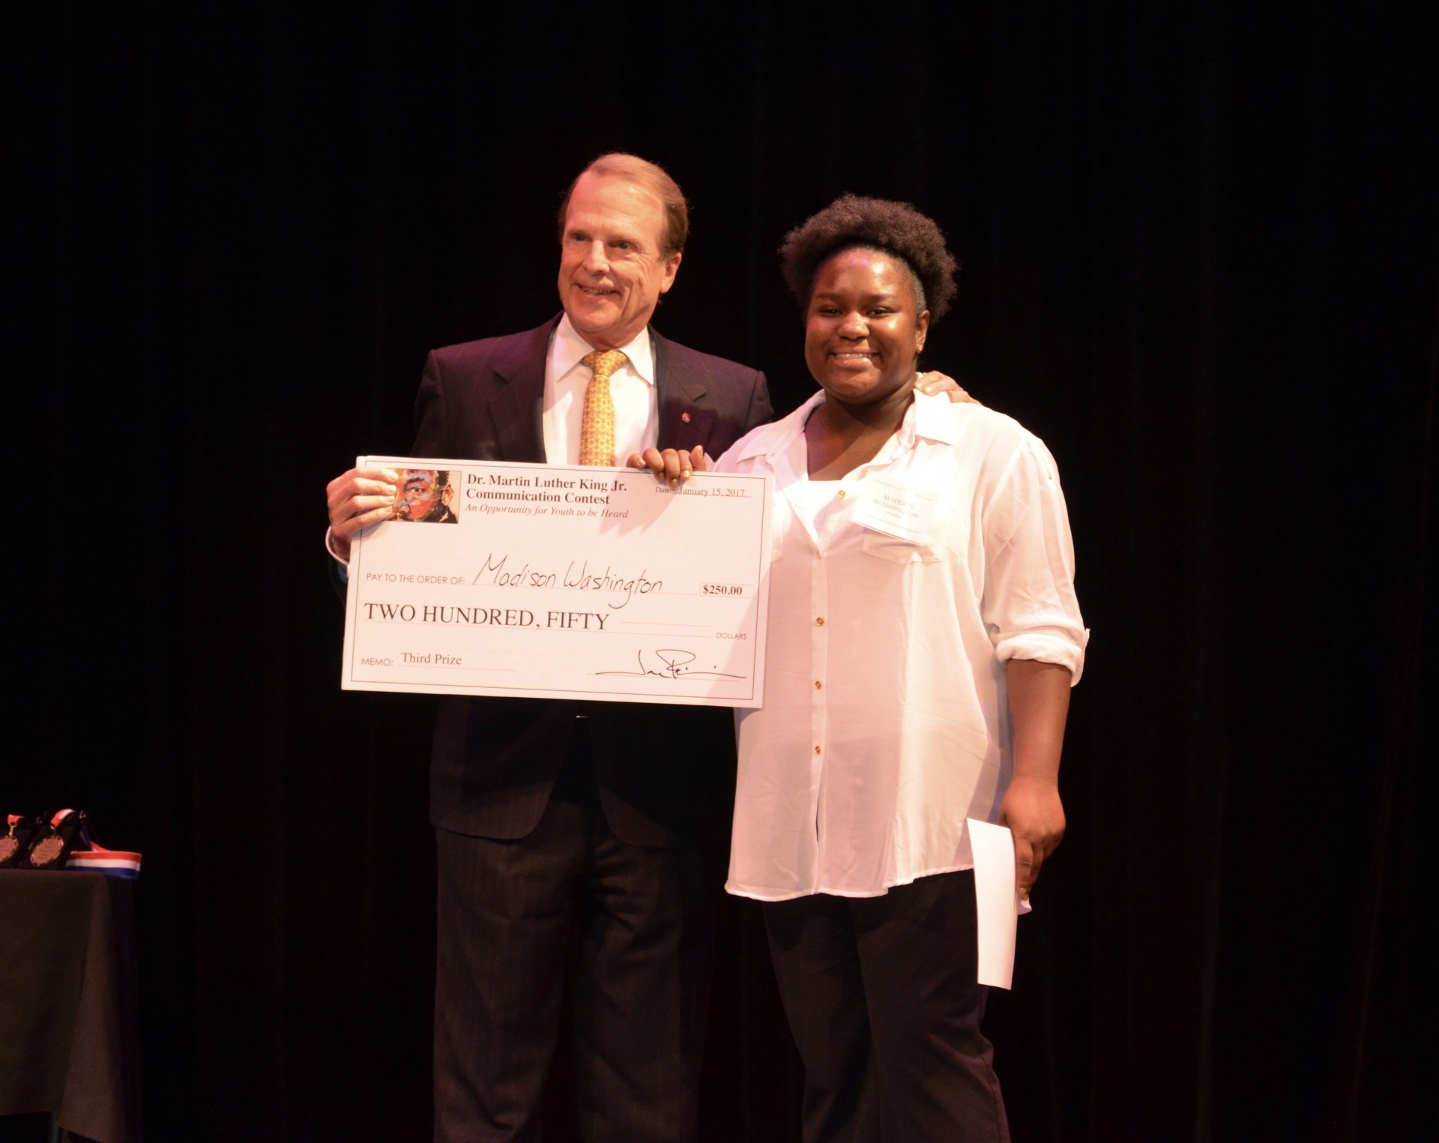
President, Kai Lassen & 3rd Place Winner, Madison Washington

WE ARE GETTING CLOSER TO OUR NEW WEBSITE
We are building a new website that will be full of
great new content and easier to use
Please be patient with us until the new site is up and fully functional.
There will be no charge payments taken at this time or
scanners for attendance – you will need to sign in.
We will keep you informed of the progress.
COMMITTEE MEETINGS / DATES / EVENTS
January 25 Board Meeting, 8:00 am
February 9 Special Evening Activity – NO MEETING
February 22 Board Meeting, 8:00 am, Howard High School

