
The Rotary Club of Wilmington, Delaware
Celebrating over 100 Years of Fellowship and Service
ISSUE 9 2016-2017 SEPTEMBER 8 – SEPTEMBER 15
UPCOMING PROGRAMS

September 8
Wilmington Mayoral Joint Appearance
Candidates: Maria Cabrera, Theo Gregory, Norman Griffiths, Kevin Kelley,
Bob Marshall, Mike Purzycki, Eugene Young
Program Chair: Sam Waltz
Menu: Vegetable Strudel with Roasted Red Pepper Sauce

September 15 – District 7630 Governor Clif Hutton
Program Chair: David Kubacki
Menu: Grilled Chicken with Roasted Corn Salsa

September 22 – Robert Buccini, Buccini-Pollin Group
Program Chair: Will Minster
Menu: Meatloaf Roulade with Roasted Red Peppers, Spinach, Fontina Cheese & Beef Gravy

September 29 – Congressional Joint Appearance
This date is set aside for a Joint Appearance -- not a debate -- between the two major party candidates for US Congress from Delaware to succeed Cong. John Carney. Republican candidate is Hans Riegel, but the Democrats have six candidates, so the program will be confirmed when the Democrats have picked their candidate in the 13 September primary election.
Program Chair: Sam Waltz
Menu: Pork Cutlet with Cranberry Demi

October 6 – Terry Holt, Partner, HDMK
“An Election Preview: Trump vs. Clinton and the World Thereafter”
Program Chair: Matt Beardwood
Menu: Salmon with Champagne Mustard Sauce

October 13 – Gary Wagner, Regional Economist, Federal Reserve Bank
Program Chair: TBA
Menu: Eggplant Parmesan

New Member – JIM LEE
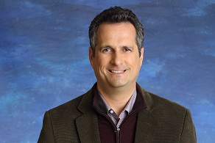
Proposer: Joan Sharp Seconders: Kate Cowperthwait, Richard Stat
James H. Lee ("Jim") has a long and successful track record in investment management and research. Prior to founding StratFI, he led the investment committee and managed more than $700 million at Lau Associates, now a part of Bryn Mawr Trust. As a popular keynote speaker and presenter on trends, Jim has traveled throughout the country and abroad, sharing his unique insights on "what happens next?" He is an active member of the Association of Professional Futurists (APF) and holds multiple well-respected professional certification. Jim and his wife, Stephanie, reside in Wilmington. He holds a B.A. degree in Economics from the College of William & Mary and an M.S. in Studies of the Future from the University of Houston-Clear Lake. In his free time, Jim enjoys biking and cooking with his wife, Stephanie.

Minutes for Meeting of September 1, 2016
President Kai Lassen called the meeting to order at 12:10pm at the Hotel du Pont's du Barry Room. The Club joined together in singing “My Country ‘Tis of Thee” led by Pete Booker with Anne Eidschun on the piano. Yair Robinson provided the invocation.
Announcements: President Kai welcomed several guests. President Kai thanked Rotarians who volunteered last week with the back pack stuffing and Back Pack Give Away and Community Back-to-School party last week for the Stubbs Elementary School Project. President Kai called on Steve Novack who provided an update on the Stubbs Elementary School Project. The aforementioned events last week were a success – thank you! Steve mentioned that two copies of the dictionaries that were distributed last week are on the tables for reference. The dictionaries are customized for third graders and contain 35,000 words and additional useful information such as weights and measures, multiplication tables, The Declaration of Independence, and maps of the world. The outside back cover of each dictionary has a Rotary Club of Wilmington label that includes The Four-Way Test. President Kai reminded us to remit our quarterly payment for dues and lunch fees. He mentioned details of the next 3 meetings, and our club will host District 7630 Governor Clif Hutton on September 15 – your calendars, please!
Program: Matt Stehl introduced our guest speaker, Tim McDermott, and as part of the introduction, Pete Booker played an audio of a Philadelphia Union cheer that can be heard at the games. Mr. McDermott currently serves as the Chief Business Officer of the Philadelphia Union. The program format consisted of a brief overview of Major League Soccer provided by Mr. McDermott and a Q&A session led by Matt Stehl. Mr. McDermott’s primary responsibility is to lead the Philadelphia Union business enterprise, which consists of Major League Soccer Philadelphia Union and Minor League Soccer Bethlehem Steel. He provides strategy and execution of plans to increase ticket sales and sponsorship and all other business items pertaining to effectively managing the enterprise. Mr. McDermott also highlighted a core strategy of identifying opportunities to strengthen the enterprise’s brand. Fun Soccer Facts: more youth participate in soccer than baseball, football, and basketball combined; National Major League Soccer (MLS) attendance is greater than NBA and NHL attendance; the Philadelphia Union’s core fan base resides in Chester, Montgomery, and Delaware counties; MLS has been touted as the ‘next big thing in sports’ for the past 20 years; MLS tickets are the most affordable of all the Major League sports; MLS is poised for the most growth among all Major League sports; players run an average of 8 – 9 miles per game; the Philadelphia Union’s stadium capacity is 18,500; and the team’s salaries range from $70,000 to $6,000,000. Primary drivers that support the claim that Major League soccer is the ‘next big thing in sports’ are: large number of youth participation; ease of and variety of electronic access to view games; professional MLS career/playing opportunities; and favorable compensation to professional players.
Why you should attend a Philadelphia Union game! 1) the view of the stadium and water is spectacular; 2) the average ticket price is $20 compared to the average ticket price of over $100 for all other Major League Sports; 3) the energy from the fans at the games is electric! 4) the current roster consists of many strong players so the Union is well positioned for the next four years to offer viewers the chance to see a GREAT game; and 5) the team members ‘represent Philadelphia’ with their display of a blue collar attitude with the right amount of toughness and resilience that one would expect from Philly! The meeting ended at 1:30 pm. Committee meetings : Music, Public Relations, Rotary Information, Youth Services. Respectfully submitted, Cindy Campanella
VERY SPECIAL FIRST-TIME GUESTS
Wellington and Brody
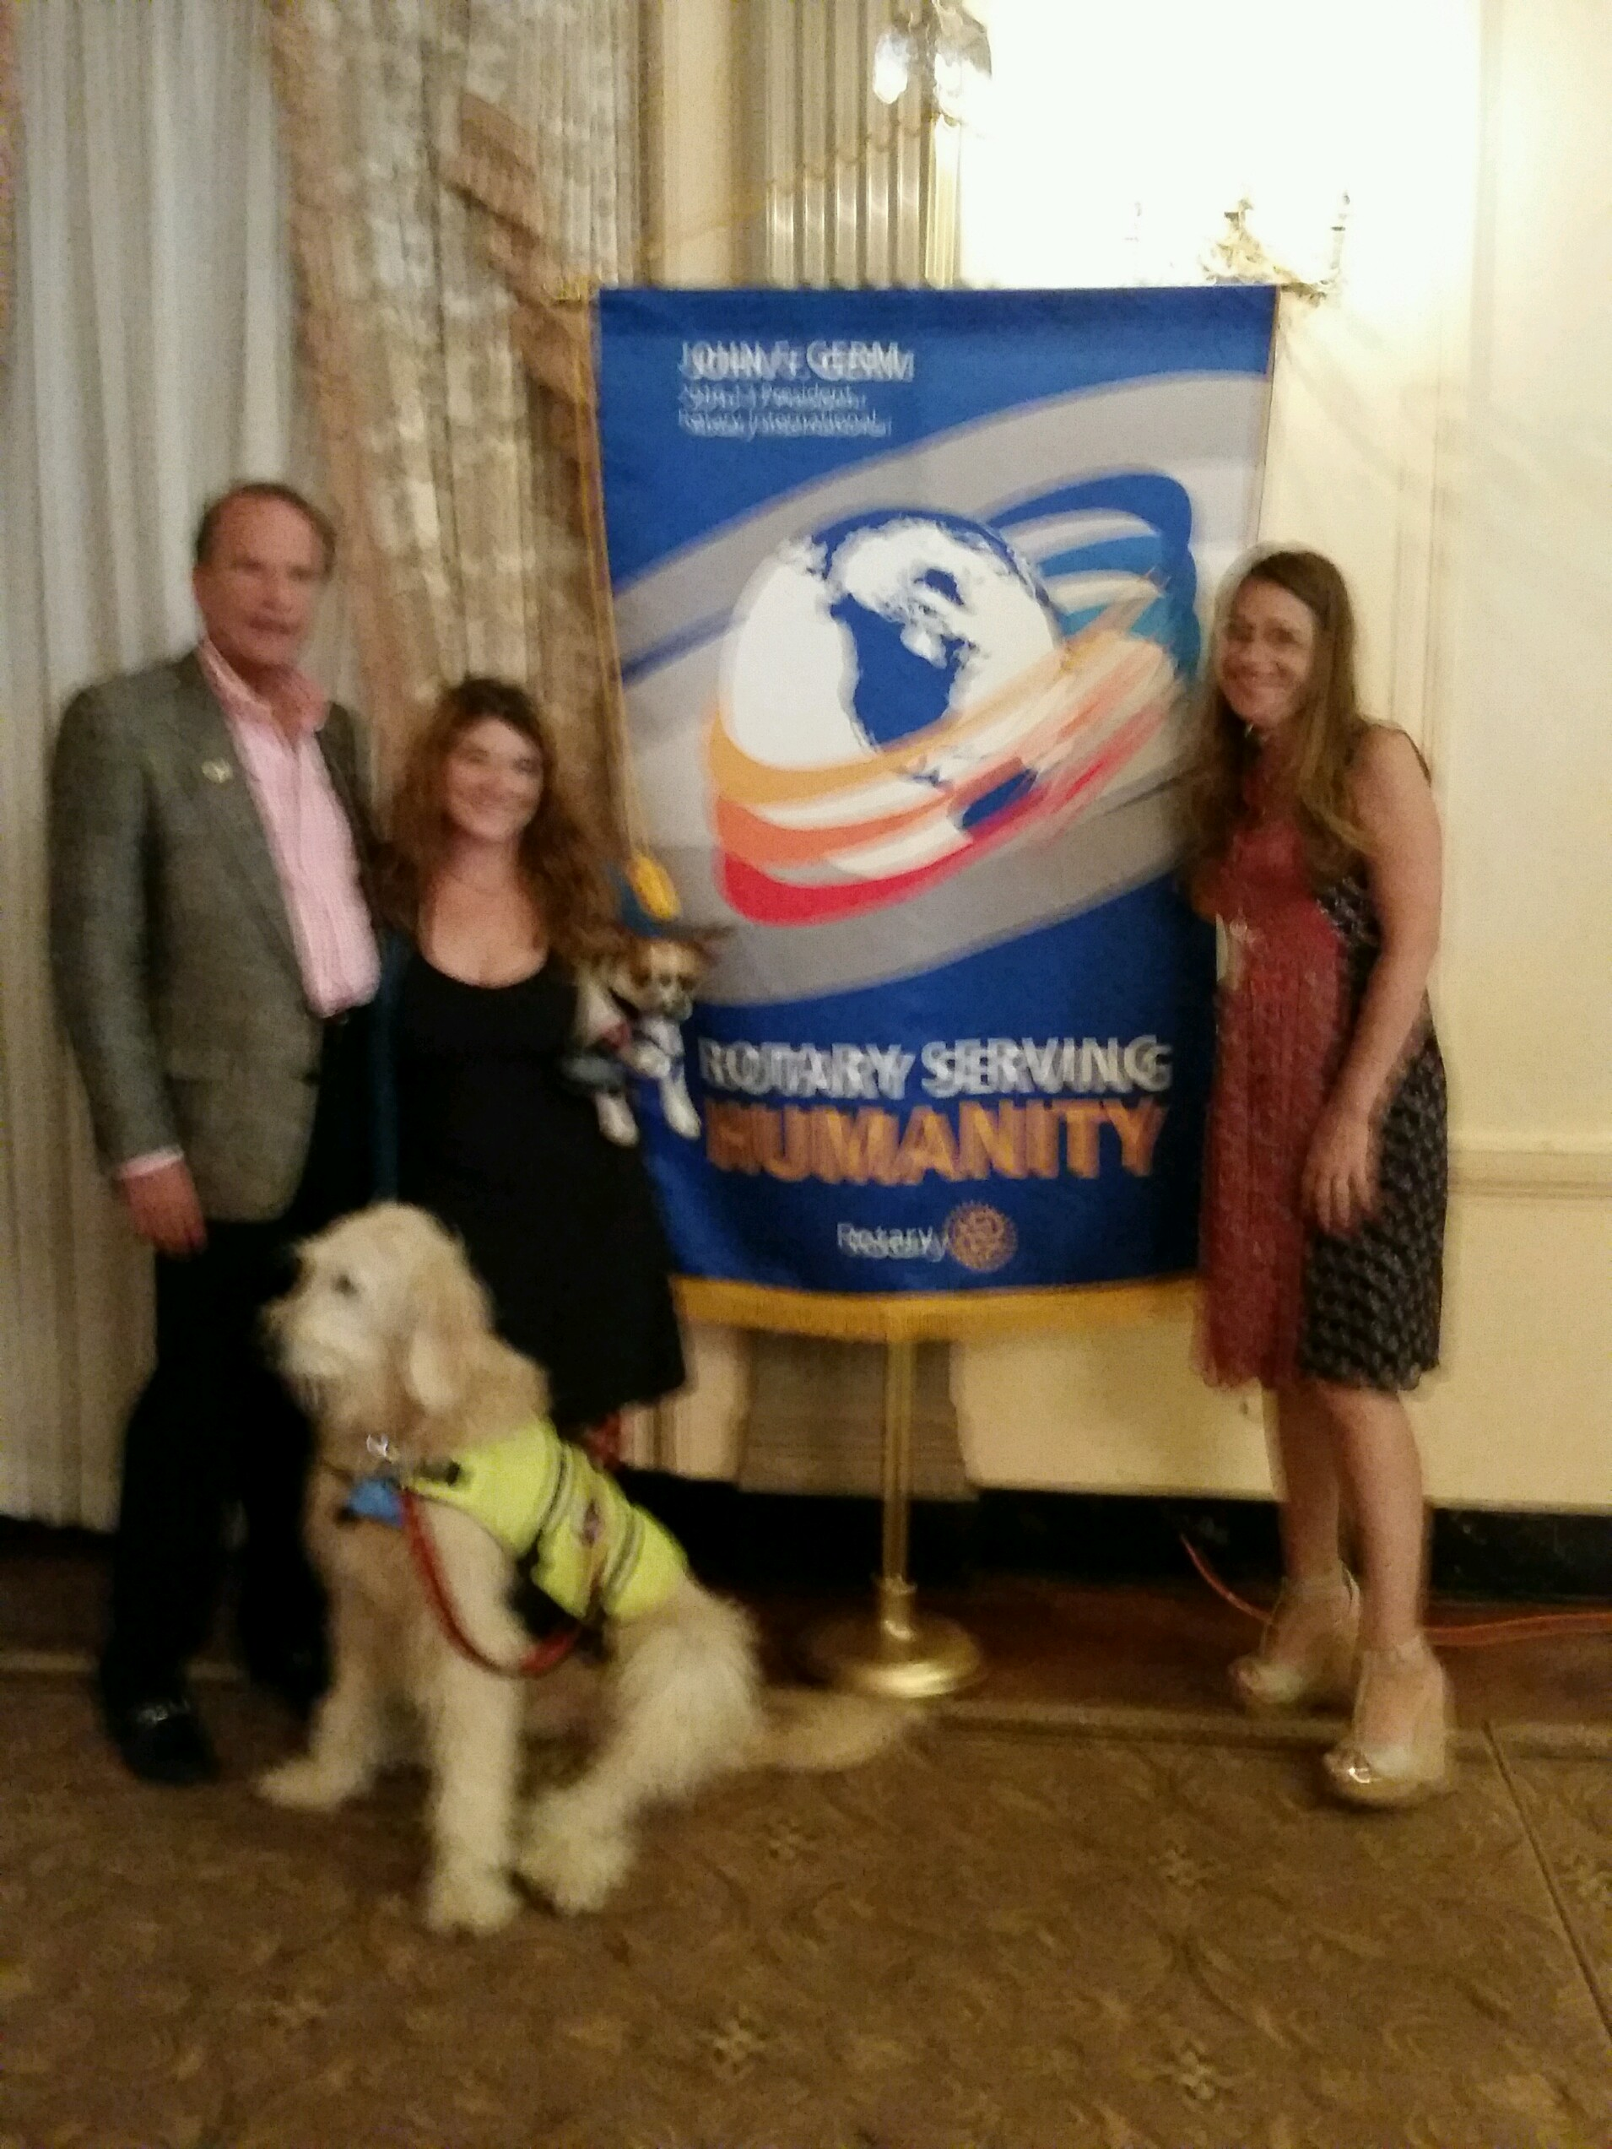
President Kai, Adriana LaCorte, Pina De Rosa and their traveling companions

$$$$$$$$$$$$$$$$$$$$$$$$$$$$$$$$$$$$$$$$$$$$$$$$$$$$$
ALL QUARTERLY INVOICES MUST BE CURRENT BY SEPTEMBER 30
$$$$$$$$$$$$$$$$$$$$$$$$$$$$$$$$$$$$$$$$$$$$$$$$$$$$$$

COMMITTEE MEETINGS / DATES / EVENT
September 8 Connections & Outreach, International, Rotary Foundation
September 15 District 7630 Governor Clif Hutton Visit
September 28 Board of Directors Meeting, 8:00 am, Hotel du Pont
Committee Chairs Invited: Centennial Park & Programming, Public Relations
October 22 Rotary Leadership Institute
RI President

