
The Rotary Club of Wilmington, Delaware
Celebrating over 100 Years of Fellowship and Service
ISSUE 8 2016-2017 SEPTEMBER 1 – SEPTEMBER 8
UPCOMING PROGRAMS

September 1
Tim McDermott, Chief Business Officer
Philadelphia Union
“A Conversation with Tim McDermott”
Program Chair: Matt Stehl
Menu: Cracker-Crusted Haddock with Wild Rice

September 8 – Wilmington Mayoral Joint Appearance
Program Chair: Sam Waltz
Menu: Vegetable Strudel with Roasted Red Pepper Sauce

September 15 – District 7630 Governor Clif Hutton
Program Chair: Kai Lassen
Menu: Grilled Chicken with Roasted Corn Salsa

September 22 – Robert Buccini, Buccini-Pollin Group
Program Chair: Will Minster
Menu: Meatloaf Roulade with Roasted Red Peppers, Spinach, Fontina Cheese & Beef Gravy

September 29 – Congressional Joint Appeearance
Program Chair: Sam Waltz
Menu: Pork Cutlet with Cranberry Demi

THANK YOU ROTARY CLUB OF WILMINGTON
Happiness is . . .
A BRAND NEW BACK PACK FILLED WITH SCHOOL SUPPLIES
Stubbs School, Thursday, August 25

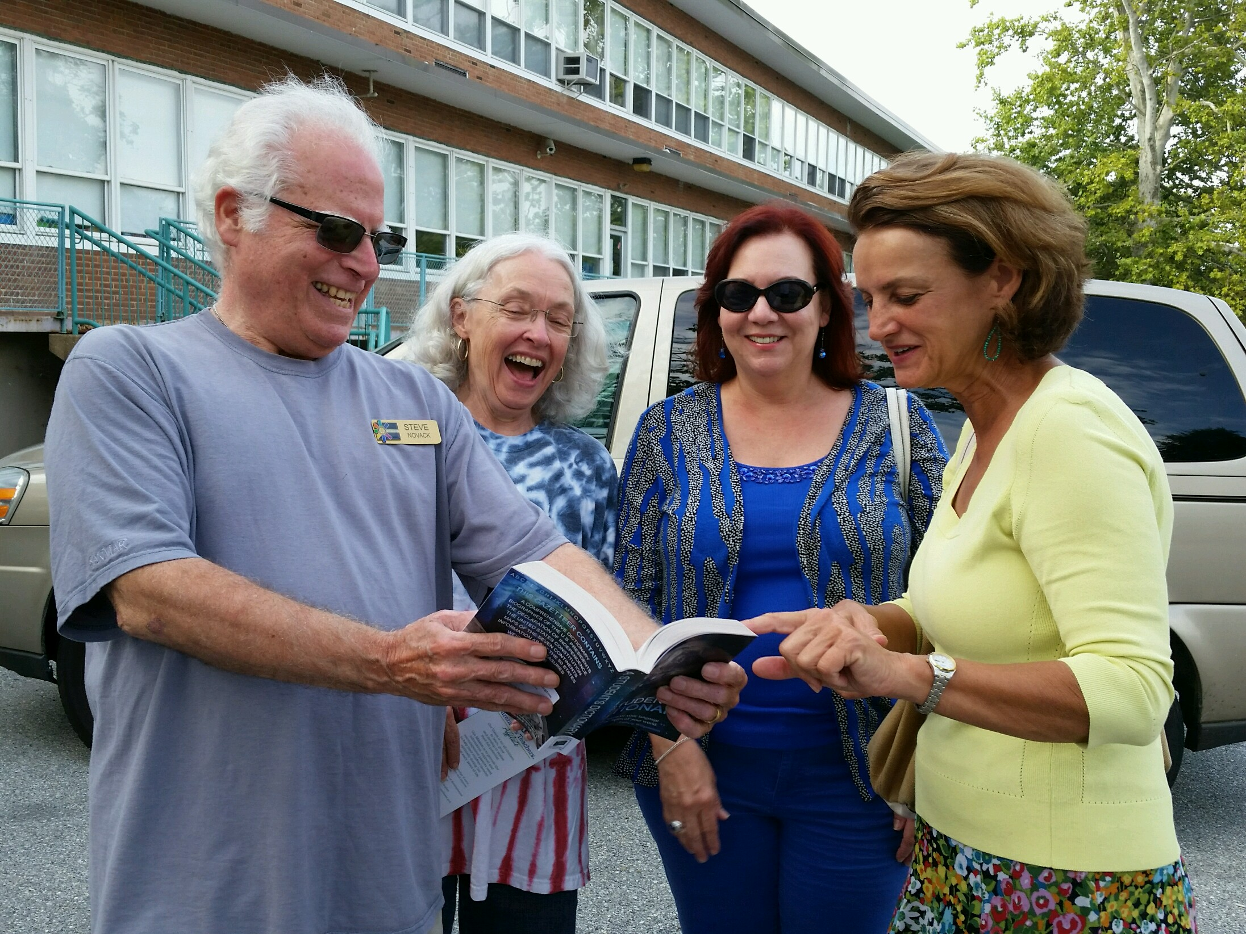

Minutes for Meeting of August 25, 2016

President Kai Lassen called the meeting to order at 12:10pm at the Hotel du Pont. The Club joined together in singing “The Star Spangled Banner” led by Michael Arrington with Elizabeth Rhoads on the piano. Cynthia Morgan provided the invocation.
Announcements: President Kai welcomed several guests. President Kai then called on Dave Fleming who provided an update on the Stubbs Elementary School Project. The back pack stuffing on Tuesday, August 23rd was a success and everyone is invited to the school’s Back Pack Give Away and Community Back-to-School party today from 4:00 –6:00pm. President Kai reminded us to remit our quarterly payment for dues and lunch fees. He mentioned details of the next 3 meetings, and our club will host District 7630 Governor Clif Hutton on September 15 – mark you calendars, please! The Club joined together in singing “You’re a Grand Old Flag” led by Michael Arrington with Elizabeth Rhoads on the piano.
Program: Ajit George introduced our speakers, Adriana LaCorte and Pina DeRosa, freelance documentary producers. Ms. LaCorte and Ms. DeRosa presented the previous day at the Wilmington TedX Salon and we were pleased that they could join us today at Rotary to provide their presentation, “Sniffing Out Cancer: The Making of a Groundbreaking Documentary about Early Cancer Detection.” Ms. DeRosa is an author and mindset effectiveness expert and college coach who has a shared passion with Ms. LaCorte, the primary producer of the dogs detecting cancer documentary. Ms. DeRosa’s Indiegogo Campaign and her affiliation with philanthropists have provided essential funding for the documentary. Ms. LaCorte is the primary producer and she has conducted over 50 interviews with trainers, patients, and medical personnel in preparing the documentary.
They shared a portion of a video detailing the story of dogs sniffing out cancer. Our presenters mentioned that 1 in 2 men and 1 in 3 women will be affected by cancer. It has been scientifically proven that dogs can detect cancer early (at stages 0 and 1) in humans with a nearly 99% accuracy rate, which is greater accuracy than any modern medical equipment. The first documentation of this discovery was in The Lancet medical journal in 1989. This early detection success by dogs has been strongly linked to lung, breast, and ovarian cancers through breath samples. Colorectal, prostate, and bladder cancers in urine samples experience the same success rate. Melanoma has been detected on the skin and ovarian and breast cancers in plasma have been discovered through dog detection. No machine or diagnostic test in the world comes close to the dog's nose, in sensitivity or specificity. Firefighters are at the highest risk of cancer and the International Firefighter Cancer Foundation (IFCF) put trust in canine cancer screening, which has already begun to save lives.
The undeniable fact is most cancers are often detected at a stage where it is not easily curable, so early detection is THE critical answer to saving lives. Dina Zaphiris trains dogs to detect cancer early and one way is through breath samples. Cancer cells appear to give off waste products and these compounds are detected by trained dogs. Dogs are trained on biopsied confirmed samples (breath, skin, urine, etc.) but there have been no official medical trials conducted. The concept of dogs detecting cancer is both groundbreaking and lifesaving. The goal of the presenters and other individuals worldwide dedicated to this field is to eventually receive FDA approval. In the interim, everyone is encouraged to spread the word by sharing the website: www.SniffingOutCancer.com. The meeting ended at 1:30 pm. Respectfully submitted, Cindy Campanella

$$$$$$$$$$$$$$$$$$$$$$$$$$$$$$$$$$$$$$$$$$$$$$$$$$$$$
IMPORTANT TO KEEP YOUR CLUB ACCOUNT CURRENT
$$$$$$$$$$$$$$$$$$$$$$$$$$$$$$$$$$$$$$$$$$$$$$$$$$$$$$
COMMITTEE MEETINGS / DATES / EVENT
September 1 Music, Public Relations, Rotary Info, Youth Svcs
September 8 Connections & Outreach, International
September 15 District 7630 Governor Clif Hutton Visit
September 28 Board of Directors Meeting, 8:00 am, Hotel du Pont
Committee Chairs Invited: Centennial Park & Programming, Public Relations
RI President

