
The Rotary Club of Wilmington, Delaware
Celebrating over 100 Years of Fellowship and Service
ISSUE 31 2016-2017 MARCH 9 – MARCH 16
UPCOMING PROGRAMS
March 9
Catherine Lindroth, Executive Director
Summer Collaborative
A program which improves programming for
disadvantaged Wilmington youth
Program Chair: Marsha Borin
Menu: Chicken Breast with Sweet Chile Glaze

March 16 – Jeff Downing, Executive Director, Mt. Cuba Center
“Mt. Cuba Center, a Jewel of the Brandywine Valley”
Program Chair: Pam Sapko
Menu: Corned Beef and Cabbage, Au Gratin Potatoes
March 23 – Dr. Robert Jordon, Former Geologist, State of Delaware
“Mason, Dixon, and the Quest for Oil”
Program Chair: Sue Knisely
Menu: Baked Salmon with Apple Cider Sauce
March 30 – Mark P. Vergnano, President & CEO, The Chemours Company
Program Chair: Bob Reardon
Menu: Vegetable Cous Cous Strudel with Lemon Chive


Mulch Madness - Saturday, March 18 ** 8:30 – 10:30 am
A great Project – A great Time – A great way to Serve
Sign Up in Lobby or with Sue
R Y L A 2017
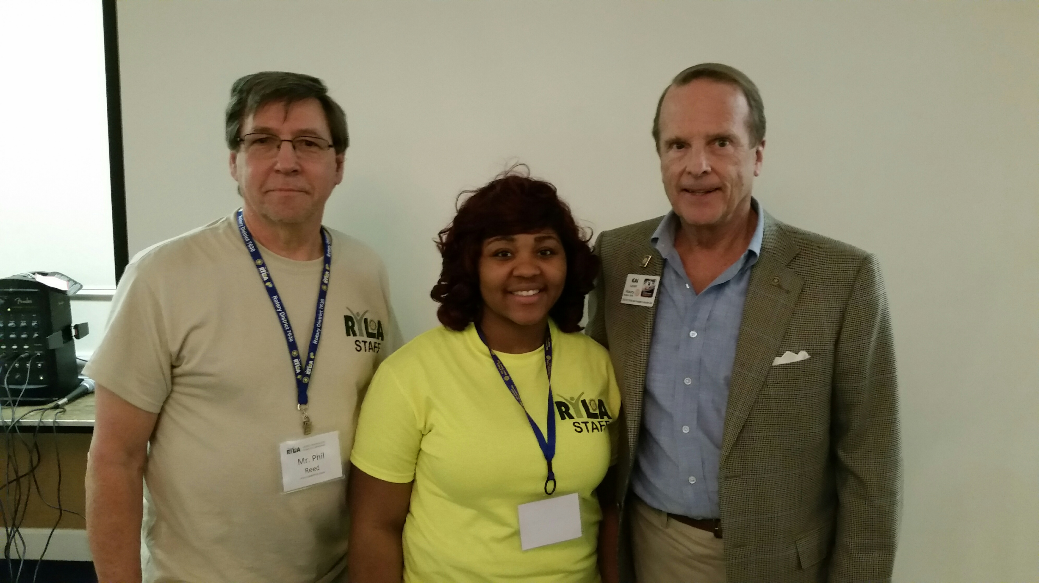
RYLA Rotaractor Lasheda Brooks from Washington College was presented with a PHF at RYLA on February 19 for being the top Rotaract counselor at RYLA this year. Pictured above is Phil Reed, RYLA District Chair from the Cambridge Rotary Club, PHF LaSheda, and President Kai Lassen.

Minutes for Meeting of March 2, 2017
President Kai Lassen called the meeting to order at 12:10pm at the Hotel du Pont’s Gold Ballroom. The Club joined together in singing “America, the Beautiful” led by Bill Holloway accompanied by Anne Eidschun on the piano. Jim Wilson provided the invocation.
Announcements: President Kai made the following announcements – Bill Jensen’s wife, Aase, died peacefully at home last week after a long illness. We send our condolences to Bill and his family. Please sign the card that is circulating and return it to Sue; please join us for the Can-Do Playground Clean Up on Saturday, March 18 from 8:30am – 10:30am; our new website is live and Pete Booker will provide an overview of the new website at our meeting next week; Cathy Kanefsky – thanks to everyone who completed the handout last week soliciting your favorite Rotary memories and Cathy shared a few with the Club. She also shared the benefits of being a Rotarian and she mentioned that there are approximately 25 guests who have received a membership application for review and consideration; Mac Sommerlatte – announced the University for a Day event scheduled for March 4 from 9:30am – 1:00pm at Memorial Hall, on the University of Delaware campus, featuring three thought provoking lectures by University of Delaware faculty members. Please see the flyers on the tables for more details; Wil Sherk – please join us at the Horty home for a Wilmington World Class Dialogue event on Thursday, March 23rd from 5:30 – 7:00pm and you can sign up in the lobby after the meeting; and Rick Gessner– announced an event this Friday evening at 5:30pm at Christ Church Christiana Hundred, titled Homeless to Homes: An Evening with Kathy Izard.
Program: Joan DelFattore provided the introduction of the head table and our speaker, Sam Beard, founder of GIFT (The Global Investment Foundation for Tomorrow).
Sam’s presentation focused on Mindfulness Meditation and the mission of GIFT is to be a major player helping to create a tidal wave expanding mindfulness and meditation around the world. For more information, please visit www.globalinvestmentfoundation.org and you may also refer to the flyers at the tables.
Recently founded and launching in Delaware, GIFT is a catalyst to open the gateways to engage 1 billion people in mindfulness practices in the next decade. Sam explained that there is no greater hope and promise for securing peace, well-being and sustainable life on earth than harnessing the revolutionary power of mindfulness and that the power of the mind remains the humanity’s greatest unexplored frontier. He invited us to practice this daily in an effort to quiet our minds and improve our capacity to connect with others. Ideally, if you can elevate yourself then you can help elevate the world. He advised us to continue to maximize the following well-being facets of our lives: physical, mental, emotional, and spiritual.
Sam invited two local Delaware professionals to share their positive experiences with mindfulness meditation. One of these individuals, Jenna, is a clinical psychologist at the Wilmington VA Medical Center and she has successfully incorporated Mindfulness Meditation into patient treatment and has taught this methodology to over 150 veterans. Sam closed with saying that each of us is unique and we have a significant purpose in life! The meeting ended at 1:30 pm. Respectfully submitted, Cindy Campanella


www.rotarywilmington.org
Our new website is now LIVE ! ! ! !
Check it OUT ! ! ! !
Update your Information, Pay Dues,
Still a Work in Progress - We would like your Input

COMMITTEE MEETINGS / DATES / EVENTS
Mar 18 Can-Do Playground Clean Up, 8:30-10:30 am
April 17 Scholarship Applications Deadline
April 21-22 Camp Fairlee Clean Up
April 22 RLI, Maple Dale CC, Dover, DE, Registration 8:00am
April 27-30 District Conference, Dover Downs, Dover, DE
May 19 Camp Fairlee Campaign Celebration
May 23 President-Elect Samantha Diedrick Club Assembly, WCC
June 10-14 RI International Convention, Atlanta, GA

